
INDUSTRY REPORT
Transportation & Warehousing in the US
Mar 2026

About

IBISWorld
IBISWorld specializes in industry research with coverage on thousands of global industries. Our comprehensive data and in-depth analysis help businesses of all types gain quick and actionable insights on industries around the world. Busy professionals can spend less time researching and preparing for meetings, and more time focused on making strategic business decisions.

Table Of Contents | Standard

1. About 4
Codes 4
Definition 4
Related Terms 4
What's Included 4
Companies 5
Related Industries 5
Additional Resources 5
2. At a Glance 6
Key Takeaways 6
Products and Services 7
Major Players 8
Key External Drivers 9
Industry Structure 9
SWOT 10
Executive Summary 10
3. Performance 12
Highlights 12
Key Takeaways 12
Performance Snapshot 13
Outlook 22
Life Cycle 25
4. Products and Markets 26
Key Takeaways 26
Products and Services 26
Major Markets 32
International Trade 35
5. Geographic Breakdown 36
Key Takeaways 36
Business Locations 37
6. Competitive Forces 43
Key Takeaways 43
Concentration 43
Barriers to Entry 45
Substitutes 46
Buyer & Supplier Power 47
7. Companies 49
Key Takeaways 49
Market Share 50
Companies 51
8. External Environment 61
Key Takeaways 61
External Drivers 61
Regulation & Policy 64
Assistance 65
9. Financial Benchmarks 66
Key Takeaways 66
Cost Structure 66
Key Ratios 69
10. Key Statistics 71
Industry Data 71

1. About
https://my.ibisworld.com/us/en/industry/48-49/about

Codes
NAICS 2017 - USA | 48-49
NAICS 2022 - USA | 48-49

Definition
This sector is largely concerned with the transportation of passengers or cargo by air, rail, water and road. Providers that supply associated support services are also included in this sector.

Related Terms

AUTOMATED GUIDED VEHICLES (AGVS)
AGVs are automated robots that are often used to move and handle materials, along with other applications.

REVENUE TON MILES
A measure of freight volume. Calculated by multiplying shipped freight in tons by the number of miles it's shipped.

JONES ACT
A provision in the Merchant Marine Act that dictates that all ships carrying cargo or passengers between US ports must be US-built, US-flagged and be manned and owned by US citizens.

What's Included
- Air transportation
- Rail transportation
- Water transportation
- Road transportation
- Transit and ground passenger transportation
- Pipeline transportation
- Road transportation
- Support activities for transportation
- Postal, courier and messengers
- Warehousing and storage

Companies
- Amazon.Com, Inc.
- United States Postal Service
- FedEx Corporation
- United Parcel Service, Inc.

Related Industries

Industries in the Same Sector
- Competitors:
  - No data available
- Complementors:
  - No data available

International Industries
- Global Deep-Sea, Coastal & Inland Water Transportation
- Freight Road Transport in the UK
- Freight Forwarding Brokerages & Agencies in Mexico

Additional Resources
- US Department of Transportation
- US Army Corps of Engineers
- Federal Energy Regulatory Commission
- American Trucking Association Information

2. At a Glance
https://my.ibisworld.com/us/en/industry/48-49/at-a-glance
Revenue  $1.9tr  ’21-’26 ↑ 1.7 %  ’26-’31 ↑ 1.5 % | Employees  13m  ’21-’26 ↑ 4.1 %  ’26-’31 ↑ 3.3 % | Businesses  5m  ’21-’26 ↑ 8.0 %  ’26-’31 ↑ 7.6 %
Profit  $234.0bn  ’21-’26 ↑ 4.9 % | Profit Margin  12.4%  ’21-’26 ↑ 1.8 pp | Wages  $524.4bn  ’21-’26 ↑ 1.2 %  ’26-’31 ↑ 1.9 %

Key Takeaways

Performance
- Freight-heavy cargo markets are stuck in a low-rate, low-margin cycle while premium travel keeps growing. Excess trucking and vessel capacity are crushing rates and margins, even as higher-income air and cruise passengers become the sector’s most reliable revenue engine.
- Tariff volatility is reshaping how operators manage inventory, sourcing and compliance. Companies are front-loading imports, expanding FTZ use and buying more trade-management services, turning tariff planning and legal exposure into core parts of sector strategy.

Products and Markets
- Rail, mail and delivery services are grappling with structural headwinds. Coal’s long-running decline and USPS’s downsizing are eroding volumes and revenue, forcing networks to shrink and limiting growth potential in these once-central transport segments.
- Premium travel and healthcare logistics are now core demand engines. Higher-income air and cruise passengers and surging specialty drug volumes are driving transportation and warehousing needs, offsetting some weakness in traditional goods-heavy sectors.

Products and Services
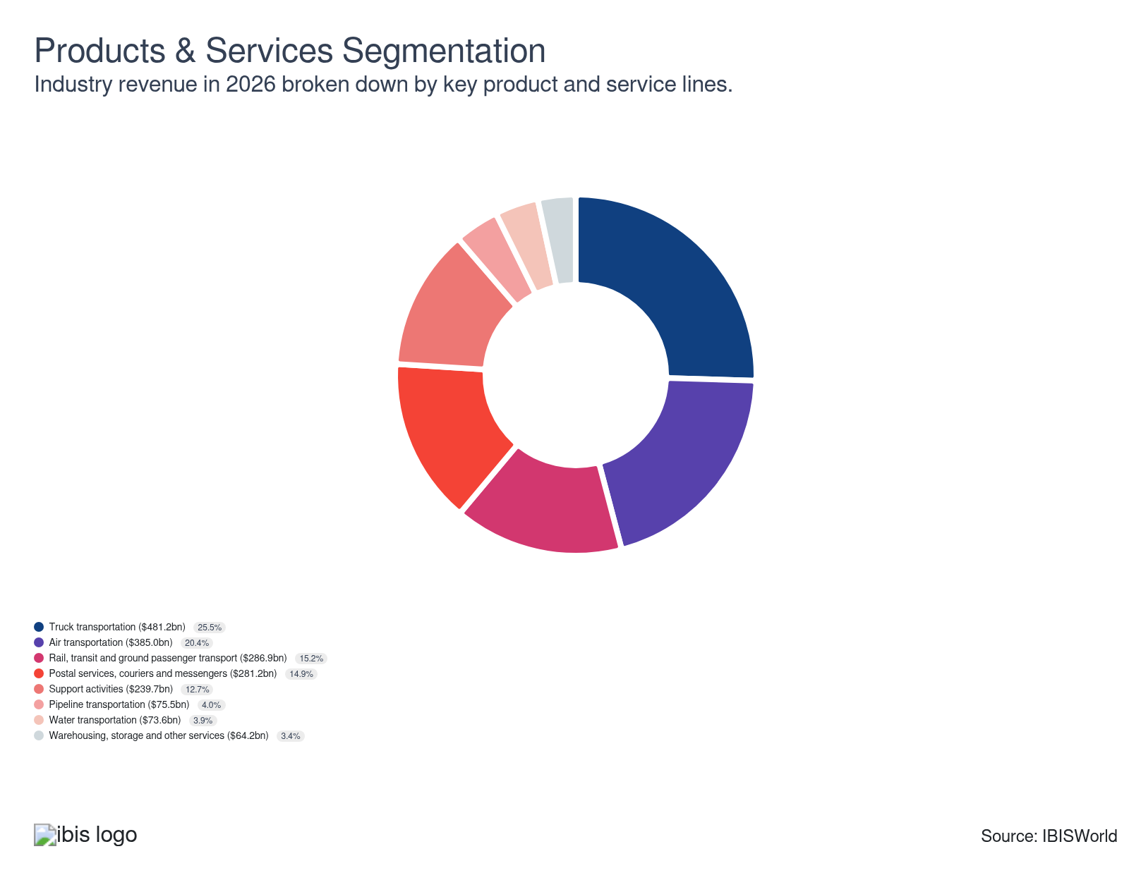

Major Players
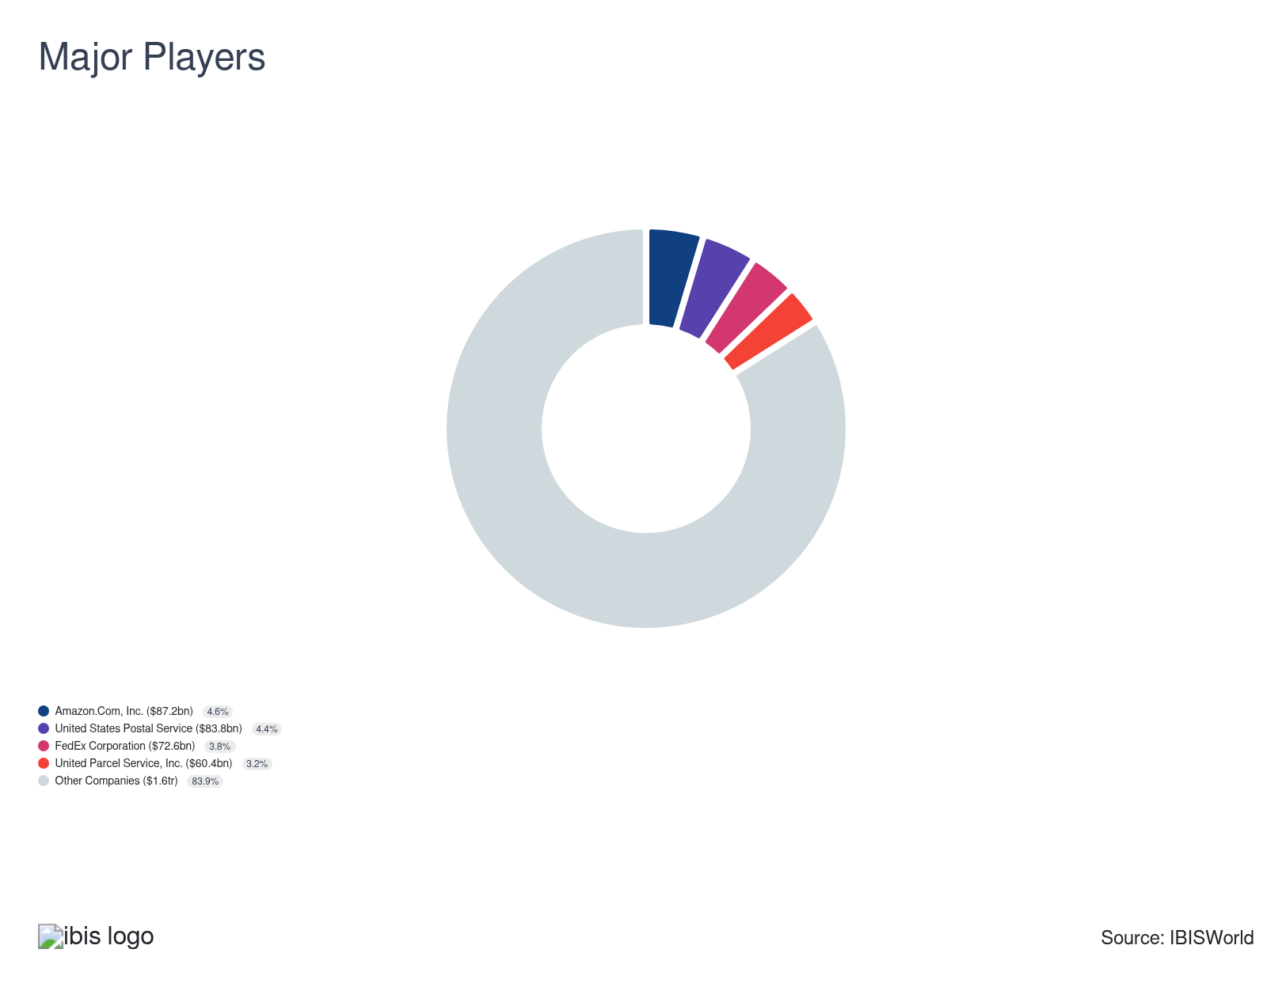

Key External Drivers
Key External Drivers | Impact
Freight transportation services index | Positive
Total trade value | Positive
Industrial production index | Positive
Business bankruptcies | Negative

Industry Structure
Characteristic | Level | Trend
Concentration | Low
Barriers To Entry | Moderate | Steady
Regulation and Policy | Moderate | Steady
Life Cycle | Growth
Revenue Volatility | Moderate
Assistance | Low | Steady
Competition | Low | Increasing
Innovation | Very High

SWOT
Strengths  High Profit vs. Sector Average  Low Customer Class Concentration  Low Product/Service Concentration | Weaknesses  Low Revenue per Employee  High Capital Requirements | Opportunities  High Revenue Growth (2021-2026)  High Revenue Growth (2026-2031)  High Performance Drivers | Threats  Low Revenue Growth (2005-2026)  Low Outlier Growth  Industrial production index

Executive Summary

Delayed: A weak freight market is squeezing cargo-heavy operators, while rising travel demand lets carriers chase affluent passengers with premium offerings as freight players cut costs to protect reliability and efficiency.
Sector growth has persisted, but pressure points remain visible. Freight demand was revised down as economic conditions softened early in the period, following a sharp run-up that gave way to a pronounced correction in cargo markets. The reversal eroded earlier gains for freight-heavy operators and prompted a reassessment of cost structures, including strategic layoffs to preserve margins as revenue expectations reset. Trucking companies have increasingly eliminated underperforming lanes rather than pursuing network expansion, signaling a tilt toward operational efficiency over volume growth. These operators also absorbed rising financial exposure from nuclear verdicts and settlements, which lifted insurance and legal costs and reinforced reliance on safety programs and risk-management strategies.
By contrast, travel recovery has supported performance in passenger-oriented segments. Internationally focused operators such as airlines and cruise lines have benefited from stronger demand among higher-income travelers, who are more willing to spend on premium cabins, lounges and luxury itineraries. Airports have captured additional non-aeronautical revenue from expanded lounge offerings and ancillary services targeting these passengers. These dynamics have underpinned profit growth even as top-line expansion remained moderate, with sector revenue rising at an estimated 2.0% CAGR over the five years to 2031, reaching about $1.9 trillion, including a 1.2% gain in 2026. Growth over the period also reflects the maturation of service lines such as returns management, which have become more important as e-commerce operators face rising error rates and rely on reverse logistics as a fee-based solution.
The outlook combines structural challenges with measured opportunities. Tariff policy continues to exert pressure and is encouraging a shift toward foreign-trade zone strategies, as warehouses aggressively pursue FTZ designations and open bonded facilities that allow goods to be received without immediate duty payments. The 2026 Supreme Court ruling against emergency reciprocal tariffs has spurred companies to seek refunds on prior-year duties, introducing potential one-time cost relief but also legal expenses and planning uncertainty. Aging infrastructure is expected to drive higher capital spending on public fleets and facilities, while airlines are anticipated to accelerate investment in predictive maintenance to control lifecycle costs. Adoption of automation, including emerging autonomous trucking solutions, is projected to ease labor cost pressures and lift productivity, though elevated cybersecurity risk will require continued IT and security investment. These competing forces are expected to constrain margin expansion but support steady revenue growth, with sector revenue projected to increase at about a 1.5% CAGR through 2031 to roughly $2.0 trillion.

3. Performance
https://my.ibisworld.com/us/en/industry/48-49/performance

Highlights
Revenue  $1.9tr  2021-26 CAGR ↑ 1.7 %  2026-31 CAGR ↑ 1.5 % | Employees  13m  2021-26 CAGR ↑ 4.1 %  2026-31 CAGR ↑ 3.3 % | Businesses  5m  2021-26 CAGR ↑ 8.0 %  2026-31 CAGR ↑ 7.6 %
Profit  $234.0bn  2021-26 CAGR ↑ 4.9 % | Profit Margin  12.4%  2021-26 CAGR ↑ 1.8 pp

Key Takeaways
- Freight-heavy cargo markets are stuck in a low-rate, low-margin cycle while premium travel keeps growing. Excess trucking and vessel capacity are crushing rates and margins, even as higher-income air and cruise passengers become the sector’s most reliable revenue engine.
- Tariff volatility is reshaping how operators manage inventory, sourcing and compliance. Companies are front-loading imports, expanding FTZ use and buying more trade-management services, turning tariff planning and legal exposure into core parts of sector strategy.

Performance Snapshot
Revenue: | ↑ 2021-26 Revenue CAGR +1.7%
Revenue  $1.9tr  ’21-’26 ↑ 1.7 %  ’26-’31 ↑ 1.5 % | 2026 Revenue Growth  ↓ 0.7 % | Revenue Volatility  Moderate
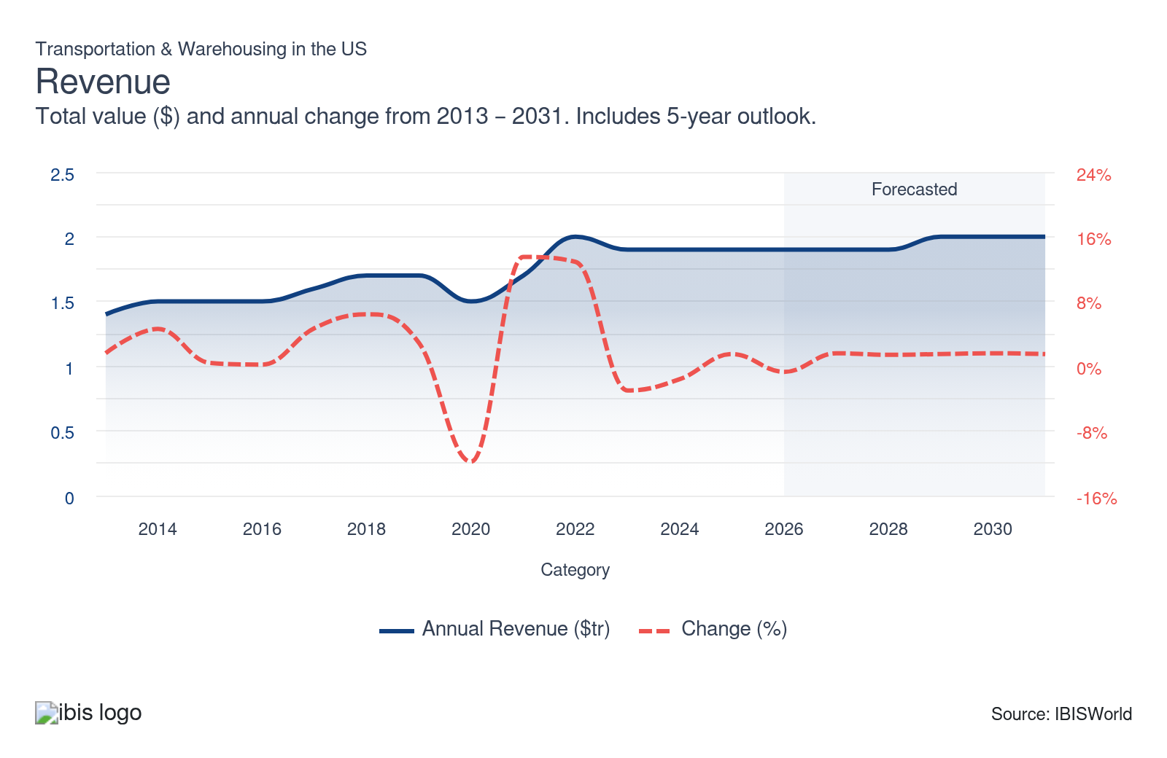
Employees: | ↑ 2021-26 Employees CAGR +4.1%
Employees  13m  ’21-’26 ↑ 4.1 %  ’26-’31 ↑ 3.3 % | Employees per Business  2  ’21-’26 ↓ 3.6 %  ’26-’31 ↓ 4.0 % | Revenue per Employee  $150k  ’21-’26 ↓ 2.4 %  ’26-’31 ↓ 1.7 %
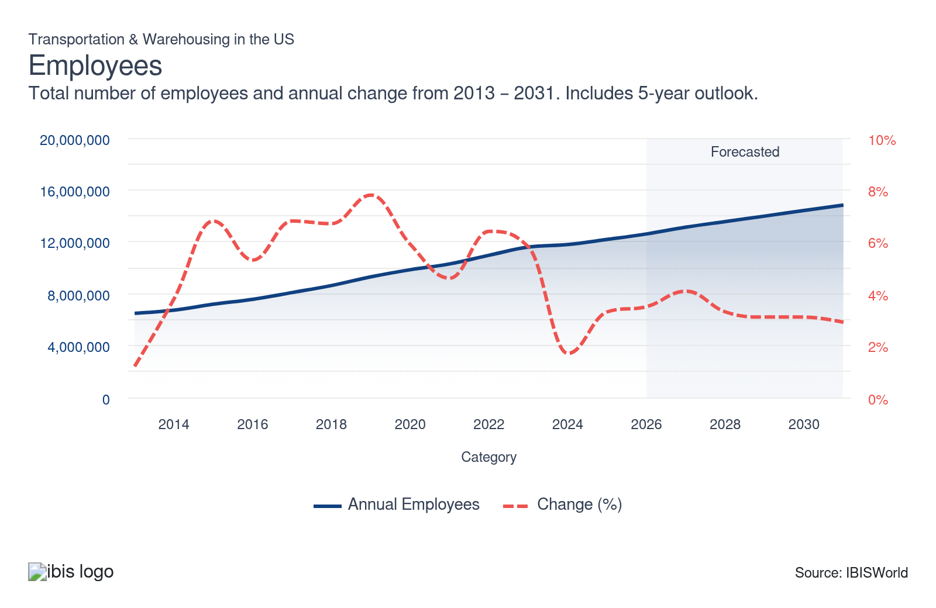
Businesses: | ↑ 2021-26 Business CAGR +8.0%
Businesses  5m  ’21-’26 ↑ 8.0 %  ’26-’31 ↑ 7.6 % | Employees per Business  2  ’21-’26 ↓ 3.6 %  ’26-’31 ↓ 4.0 % | Revenue per Business  $350.4k  ’21-’26 ↓ 5.9 %  ’26-’31 ↓ 5.6 %
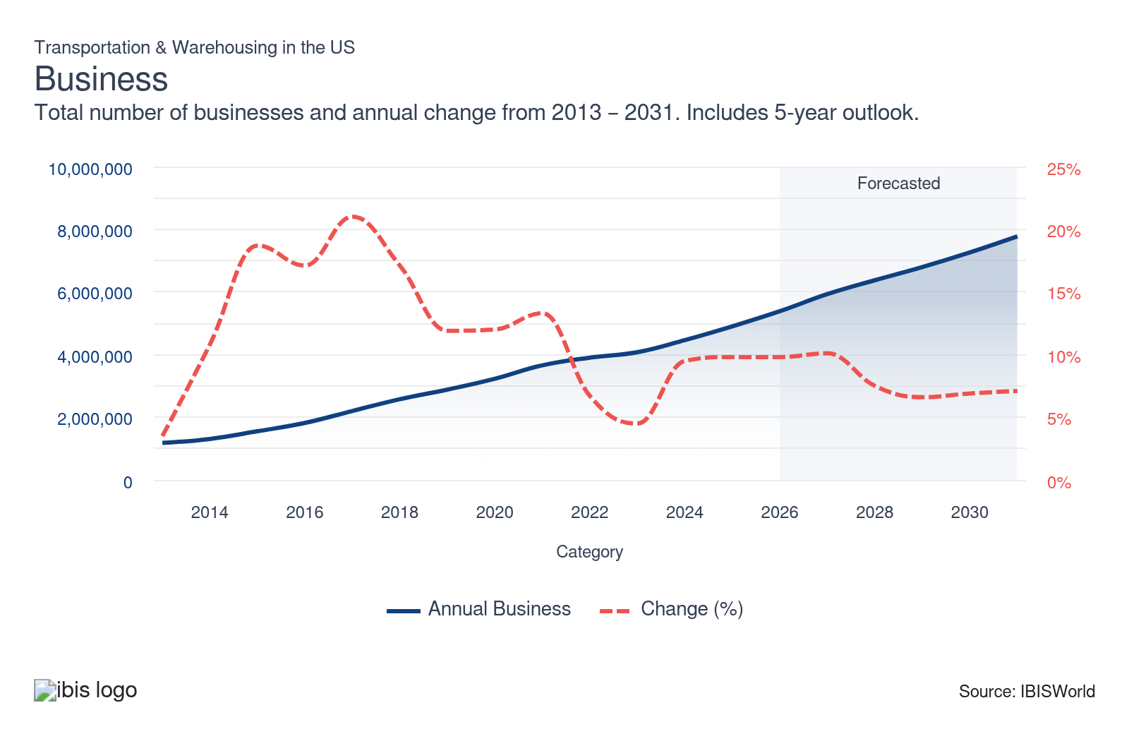
Profit: | ↑ 2021-26 Profit CAGR +4.9%
Total Profit  $234.0bn  ’21-’26 ↑ 4.9 % | Profit Margin  12.4%  ’21-’26 ↑ 1.8 pp | Profit per Business  $43,453
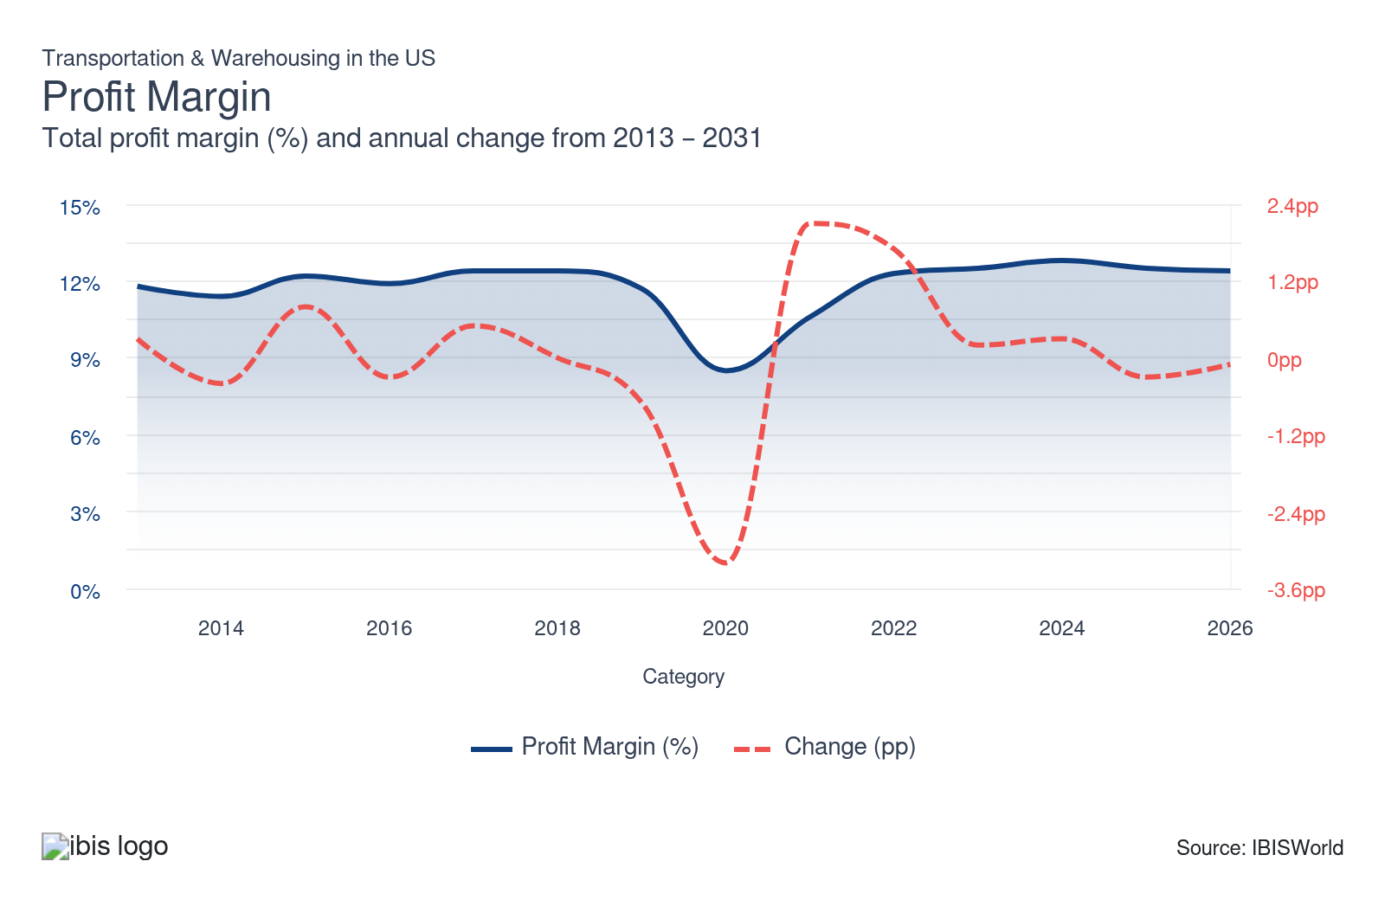
Current Performance
Current Performance

What's driving current industry performance?

Freight recession and oversupply are weighing on cargo sectors
- A prolonged freight recession is constraining transportation and warehousing performance across key modes, as excess capacity has met softening demand for goods. Capacity added through 2022 to relieve earlier bottlenecks remained in the market even as domestic goods spending slowed from 2023, leaving too many trucks, containers and vessel slots chasing fewer loads. The Cass Freight Index, which tracks North American freight volumes, was already posting year-over-year declines by the fourth quarter of 2022, and those declines deepened in 2023 to about 8.6% year over year, levels not seen since the 2020 downturn, signaling a sharp correction from pandemic-era freight activity peaks.
- Weaker volumes have translated directly into lower freight rates, particularly in ocean shipping. The Shanghai Containerized Freight Index, which measures spot container rates on routes from Shanghai to major global ports, fell below the 1,000-point range in 2023 after previously peaking in the 5,000s from late 2021 to early 2022, reflecting the normalization of demand and the impact of excess vessel capacity. Although the Red Sea security crisis in 2024 disrupted routes and temporarily pushed benchmark rates back above 1,000, pricing remained well below prior peak levels, limiting carriers' revenue recovery.
- Depressed rates and softer volumes are pressuring profitability across trucking, ocean and air cargo. Lower pricing has reduced revenue for ocean carriers and trucking firms, while airlines have seen weaker performance in belly cargo operations. The American Transportation Research Institute reported in 2025 that average operating margins for trucking carriers were about -2.3% in 2024, linking the loss-making environment to rising operating costs and lower spot and contract rates. In response, some carriers are exiting the market: Federal Motor Carrier Safety Administration data for 2025 show monthly carrier revocations in the 5,000–6,000 range versus roughly 4,500 new carrier authorities, implying a net loss of about 1,000 carriers a month.
- Operators that remain active are restructuring networks and cutting costs to protect margins. Heartland Express, for example, announced lane reductions by June 2025, citing persistently weak freight demand on specific corridors and opting to rationalize routes rather than fully exit the market. In ocean shipping, Maersk disclosed in January 2026 plans to eliminate nearly 1,000 corporate roles globally as part of efforts to adjust its cost base amid lower freight rates. These measures highlight how freight-intensive segments of the transportation and warehousing sector are relying on capacity rationalization, route pruning and headcount reductions to navigate a low-rate, low-margin environment that’s dragging on revenue and profit growth.

Premium travel demand is driving passenger transportation performance
- A large share of recent sector activity is tied to passenger travel by air and cruise, with recovery led by premium travelers rather than a broad-based rebound across income groups. International Air Transport Association data from 2023 show that, as a share of North American passenger traffic, premium travelers recovered to 108.0% of their February 2019 level, compared with 97.0% for total passengers in February 2023, indicating that higher-yield business and affluent leisure segments are returning faster and spending at greater volumes than economy travelers.
- This divergence persisted into 2024 in international air travel, as the National Travel and Tourism Office reported that the average US outbound traveler had a combined household income of $163,000, about 10.0% above 2023. This points to a demand mix that’s increasingly weighted toward higher-income passengers who are more willing to travel internationally, stay longer and pay for upgraded products, supporting revenue growth even as lower-income travelers face more binding budget constraints.
- Cruise markets are reflecting the same pattern. Despite the availability of contemporary mass-market cruises, travel agents surveyed in 2025 noted that, among 2024 travelers, the strongest and most persistent demand was in luxury and premium cruise segments, according to the Cruise Lines International Association. This indicates that a growing share of cruise spending is concentrated among wealthier clients, influencing the types of itineraries, onboard experiences and service levels operators prioritize.
- Operators and related infrastructure are adjusting their offerings to capture this higher-yield demand. Norwegian has focused on premium passengers by introducing more high-end products, including the Skyview Regent Suite in 2025, a roughly $25,000-per-night cruise experience that includes spa access and personal butlers. Regent reported that nearly half of available Skyview bookings were sold by June 2025, signaling solid interest in ultra-premium cruise products and supporting higher per-passenger revenue in an otherwise cautious spending environment.
- Airlines are following a similar strategy. Delta has pursued higher-income international travelers by launching nonstop service from Salt Lake City to Seoul-Incheon International Airport by 2025 on Airbus A350-900 aircraft outfitted with Premium Select seating, offering fully reclining seats and enhanced dining options. Airlines have also expanded lounge programs, leasing more airport space for paid rest areas and boosting non-aeronautical revenue at airports. Delta recorded a 5.0% year-over-year increase in premium-class earnings in the second quarter of 2025, even as mainline cabin segments underperformed amid economic pressure on less wealthy passengers.
- Card-spending data suggest this premium orientation is reshaping demand across income bands. Bank of America data show that, between 2019 and November 2025, the share of credit and debit card spending on airlines and cruises among households earning $50,000 to $100,000 has declined or remained muted, while spending among households earning $100,000 to more than $150,000 has increased. This shift underscores a strategic trade-off: operators risk weaker mass-market volumes but are sustaining revenue and profit by leaning into premium services for travelers who remain willing to pay more.

Free shipping expectations are reshaping logistics
- Consumer preference for free shipping continues to drive sourcing decisions and retailer selection, with 77.0% of shoppers in 2025 reporting it influences their purchases, up from 66.0% in 2020, according to AlixPartners. Retailers have responded by raising average minimum-order thresholds for free shipping to $103 in 2025, up from $82 in 2023, signaling a shift toward handling higher-value goods and reworking business models to maintain competitive incentives.
- Logistics companies see increased complexity as they process more valuable goods, driven by consumer selectiveness amid cost pressures and tariff concerns. These conditions have led shippers to tighten compliance standards and ramp up product safety measures, reflected in efforts like UPS’s $500.0 million investment in employee training to manage risks and reduce liability related to damaged goods.
- The increase in the value and flow of shipments results in a greater risk of damage, which remains a significant concern for the industry—40% of merchants highlighted damaged items as a key operational issue in a 2024 InsureShield survey. Investments in quality controls help, but a growing volume means that some damage will still occur, calling for adaptive business solutions.
- Reverse logistics has emerged as a critical revenue stream, complementing damage control and strengthening sector revenue and profitability. FedEx Easy Returns, launched in 2025, streamlines returns for customers at specialized locations and generates income for FedEx through service fees charged to retailers and merchants. Correspondingly, 92% of warehousing and fulfillment centers are now charging for returns management, a notable jump from 79.3% in 2024, according to Warehousing and Fulfillment survey data, making returns processing a core industry function.

Rising litigation and insurance costs pressure trucking expenses
- Nuclear verdicts from trucking-related lawsuits are creating financial strain across the industry. Large settlements against companies following severe accidents have raised the risk environment, even when final rulings are reduced on appeal. For instance, Wabash National Corporation was ordered to pay $462.0 million in 2024 after a fatal crash, though the amount was later cut to $108.0 million in 2025. These cases exemplify how litigation exposure has increased financial vulnerability for carriers and heightened scrutiny of safety practices.
- Escalating insurance costs are a direct consequence of this litigation trend. The Bureau of Labor Statistics reported that the producer price index for commercial auto insurance rose 2.2% year over year in 2024, reaching a record cost for the sector. Higher premiums have added to trucking companies’ operating expenses, eroding profitability at a time when labor and fuel costs remain elevated. This environment has left many companies managing tighter profit while struggling to balance cost pressures with service demand.
- Companies are responding with additional safety investments and lobbying activity to curb liability risks. The American Trucking Association (ATA) estimated that trucking entities spent $14.0 billion on safety initiatives in 2022, a 40.0% increase compared to 2015. While these expenditures weighed on profit, they strengthened operational standards and reassured clients about road safety commitments. At the same time, legal advocacy has gained traction, with tort reform ranked as the third most pressing issue for trucking companies in 2024 by the American Transportation Research Institute. This mix of compliance spending and lobbying illustrates how carriers attempt to manage rising costs and regulatory pressure tied to litigation risks.

What influences industry volatility?

Severe weather disruptions are amplifying revenue volatility
- Extreme weather events disrupt transportation capacity and scheduling, creating short, sharp swings in sector revenue and activity. Storm-related airport closures, port restrictions, and highway shutdowns temporarily halt passenger and freight movements, compressing billable volumes into narrower windows and forcing carriers to cancel or consolidate services, thereby heightening quarterly and even monthly volatility in reported revenue and throughput.
- The 2026 North American winter storm illustrates this risk concentration. American Airlines indicated in early 2026 that storm-driven airport closures could cut up to $200.0 million from its first-quarter revenue, reflecting lost flights during the event window. United Cargo temporarily suspended operations at affected airports during the same storm period, reducing air cargo uplift and exposing logistics providers to sudden drops in high-yield shipments alongside their passenger counterparts.

Increasing return rates and fraud fuel volatility
- Return rates have surged because of product issues and delivery damages. The National Retail Federation reports that annual returns rose to 16.9% in 2024 from 10.6% in 2020. E-commerce amplifies this, with online returns being 21.0% higher than in-store. Companies that excel in reverse logistics can transform these returns into revenue.
- According to Appriss Retail, fraudulent returns accounted for 15.0% of all returns in 2024, causing retail losses of nearly $103.0 billion. Some retailers imposed return fees to combat this, but an NRF survey showed that this led to a 36.0% drop in sales. These fees deter consumers and negatively impact revenue in the sector, which misses opportunities to deliver goods to retailers with fewer ongoing sales.
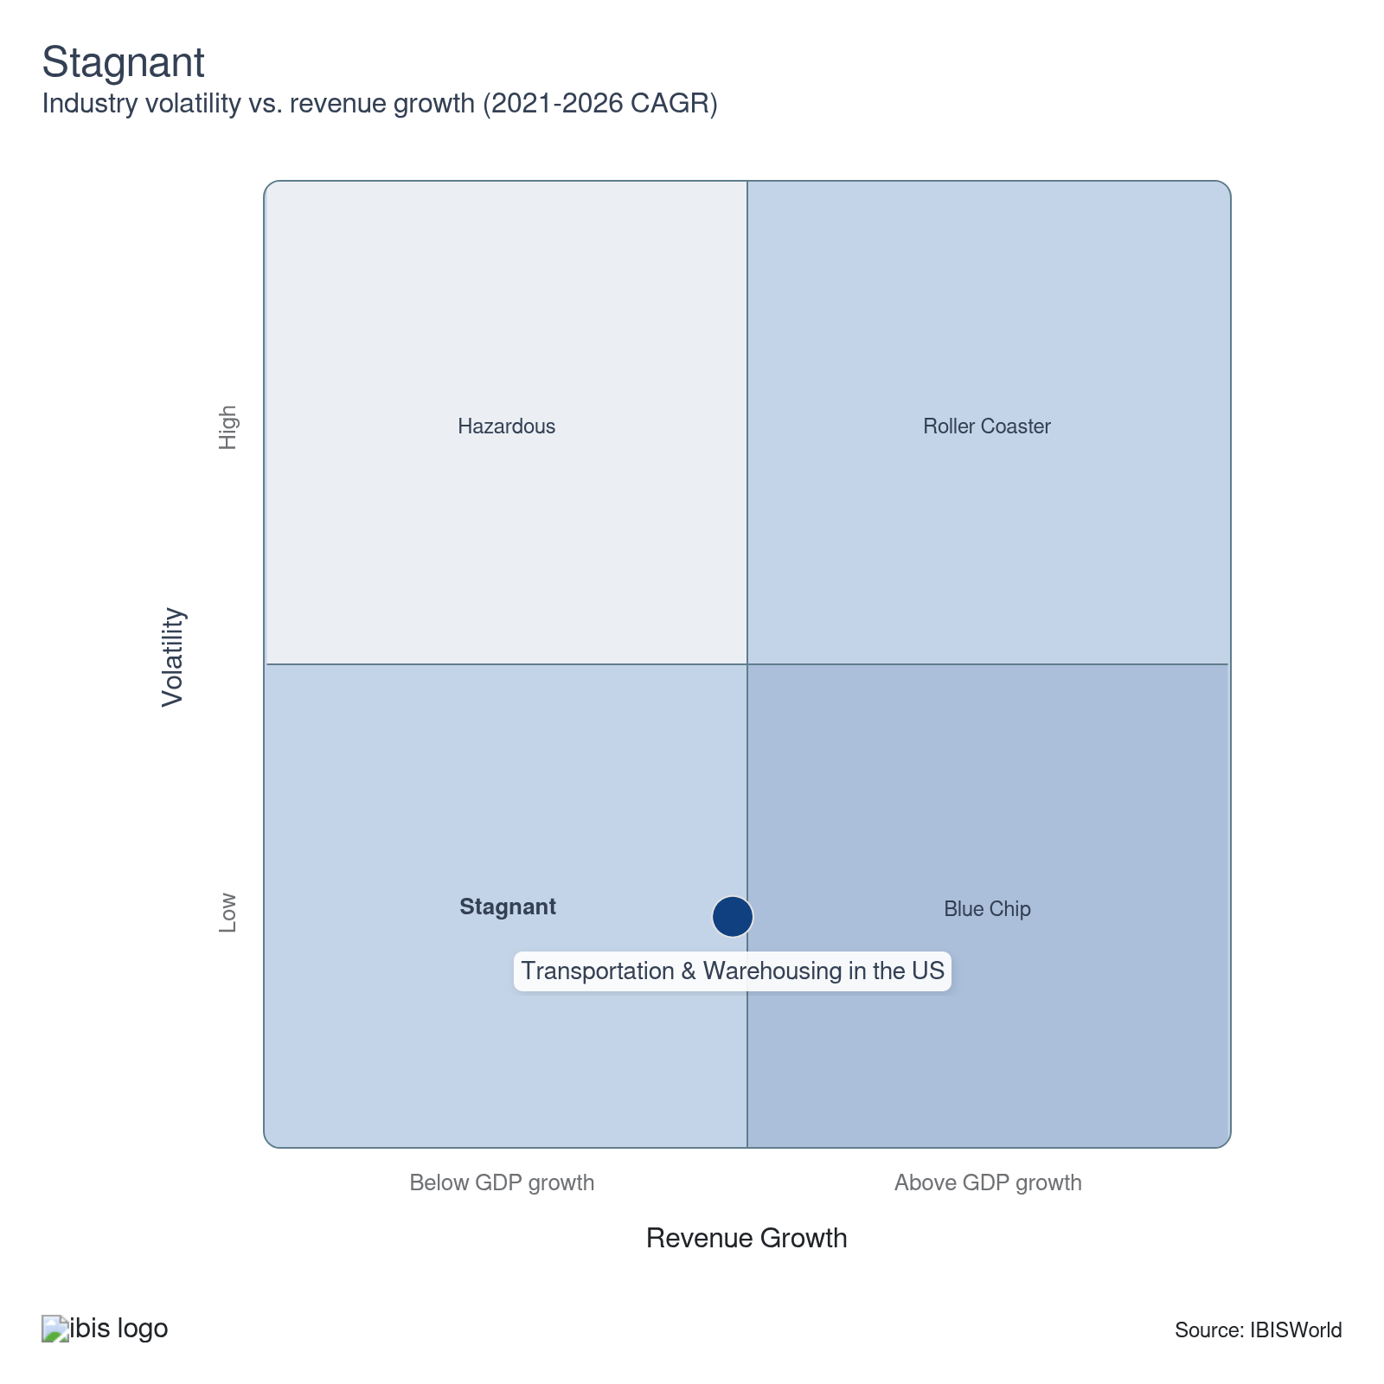

How do successful businesses overcome volatility?
Maintain efficient work practices
Adopting best practices enhances efficiency and reduces waste, helping maintain agility and cost-effectiveness during unstable times that slim their revenue.
Develop contacts within key markets
Contracts with key markets allow companies to keep their operations running even with disruptions. These markets rely on this sector, so they will spend on it no matter what, even if these disruptions impact their spending.
Outlook | ↑ 2026-31 Revenue CAGR +1.5%

What's driving the industry outlook?

Tariff shocks reshape compliance-driven sector strategy
- Shifting US tariff policy is driving divergent responses in inventory and sourcing. Many shippers accelerated orders and front-loaded goods ahead of 2025 tariff actions, while others renegotiated supplier terms to blunt the cost impact. A 2025 McKinsey survey reported that 45.0% of supply chain leaders increased inventories, 39.0% pursued dual sourcing and 33.0% leaned into nearshoring, underscoring a split between stockpiling, diversification and geographic rebalancing strategies.
- These strategies are lifting demand for foreign-trade zone FTZ services and storage-heavy warehousing. Operators have expanded FTZ offerings that allow importers to hold goods in bonded facilities without immediate duties, supporting frontloading while buyers monitor tariff developments. The National Association of Foreign-Trade Zones noted in 2025 that 49.0% of FTZ operators, including distributors and logistics companies, reported higher FTZ activity, and 83.0% expected more US FTZ applications heading into 2026, signaling strong pipeline growth for duty-deferral solutions.
- Growing regulatory complexity is pulling compliance and trade-management services into the spotlight. As companies adopt dual sourcing and nearshoring, they must navigate overlapping tariff rules, origin requirements and classification regimes, elevating trade compliance from a back-office function to a strategic priority. A 2025 Thomson Reuters survey found that 33.0% of companies saw tariff-related regulations as a top strategic focus, up from 21.0% in 2024, while Descartes reported duty-analysis service demand about 10.0% above 2019 levels in 2025, indicating renewed appetite for advisory tools that help model landed-cost scenarios and optimize routing decisions.
- Trade-policy volatility is also creating new legal exposure alongside product opportunities. Forwarders and brokers are scaling compliance platforms and tailored clearance solutions, with DHL Global Forwarding launching its DHL Consolidated Clearance Service for US imports in October 2025 to streamline customs handling and duty management. A 2026 Supreme Court ruling that AIEEPA-based tariffs were unjustified prompted FedEx and other operators to seek refunds through litigation, signaling potential one-time recoveries but also higher legal costs and renewed focus on tariff risk in medium-term planning.

Aging fleets drive a shift in sector's cost trajectory
- Aging fleets and infrastructure are lifting operating costs and constraining profit growth. Airlines, public transit operators and airports face higher maintenance and repair spending as they keep older aircraft and vehicles in service longer, with IATA estimating that production delays added about $11.0 billion in extra maintenance and leasing costs for airlines by 2025. In public transit, deferred investment needs rose from an estimated $101.4 billion in 2018 to $140.2 billion in 2022, according to FHA data, highlighting mounting backlogs that contribute to delays and disruptions as systems age.​
- These pressures are pushing operators to renew assets and modernize maintenance. New York State’s comptroller reported in 2025 that subway car issues had become the fastest-growing source of service incidents in 2024, reinforcing the case for fleet upgrades. The MTA selected Hatch Jacobs Partners in June 2025 to guide procurement of more than 1,000 subway cars and ordered at least 400 new cars for delivery from 2028, signaling higher near-term capital outlays in exchange for lower long-run maintenance costs and improved reliability.
- Digital investment, particularly in predictive maintenance, is emerging as a key cost-containment lever. In a 2025 Deloitte survey, about 47.0% of airline CEOs said AI and machine learning would be a top strategic focus over the next year, with many citing predictive maintenance as a priority use case to monitor equipment health in real time, identify emerging faults earlier and reduce unplanned downtime and repair bills across airline fleets.

Workforce shortages and automation shape sector investment outlook
- The industry faces significant workforce constraints because of demographics. According to the Bureau of Labor Statistics, in 2023, 34.0% of transit workers were 55 or older. The American Transportation Research Institute reported in 2025 that the average truck driver is 47 years old, with retirements expected to climb. These factors reduce the available labor pool while the demand for transportation services continues.
- High turnover compounds the issue. In 2021, the American Trucking Association reported driver turnover of 89.0% at large carriers and 73.0% at smaller companies. Companies have raised pay and offered bonuses to improve retention, but these measures raise costs and narrow profit. New licensing restrictions introduced in 2025, including English proficiency requirements for commercial drivers, further limit the available labor supply.
- Automation testing is now central to trucking and logistics. According to Boston Consulting Group, technology has accelerated growth and autonomous trucks are set to make up 22.0% of US long-haul truck sales by 2025. Companies recognize automation as a practical way to reduce labor costs and improve efficiency. Aurora Innovation started driverless truck trials in 2025 and plans to test in complex weather conditions in 2026. As trial results become available and more companies adopt these systems, industry reliance on automation will climb.

Cybersecurity risks and digital investments shape supply chain strategies
- The shift toward digitized supply chains is improving efficiency and raising cybersecurity concerns. Verizon reported in 2024 that 15.0% of all breaches stemmed from supply chain interconnections, up from 9.0% in 2023. These breaches expose sensitive data, disrupt operations and damage client trust, creating reputational risks for companies perceived as vulnerable. The trend underlines how growing digital integration across logistics comes with heightened exposure to cyber threats.
- Cyberattacks are also driving financial pressures. SecurityScorecard found that 57.0% of affected supply chain companies during 2025 incurred recovery costs following incidents. These expenses force businesses to redirect funds away from operations, limiting the full benefits of digitization and creating only partial savings. Companies must allocate more toward IT and security measures to reduce risks and protect customer relationships.
- Businesses are responding with technology investments and workforce training programs. In 2025, UPS announced a 10-year partnership with NTT Data to expand its artificial intelligence and cloud systems, strengthening its digital infrastructure. FedEx has updated employee training, using simulated incident scenarios to prepare staff for security breaches. These responses suggest that transportation and warehousing companies view reinforced cybersecurity as critical to sustaining digital growth. In the short term, however, rising cyber risks are expected to weigh on costs and operational decisions across the sector.
Life Cycle | Growth

Why is the industry growing?

Contribution to GDP
The sector strengthens GDP by performing an essential role in moving goods to industries and consumers across the economy. In recent years, it’s also become more travel-heavy, making passenger movement increasingly essential to travel economies and to the sector’s overall GDP contribution in the years ahead.

Market Saturation
The sector lacks market saturation because of the proliferation of companies seeking solutions to logistics challenges. In an increasingly logistically aware economy, businesses prioritize efficiency in dealing with supply chain issues, leading to increased market activity for these sector services and mitigating market saturation risks.

Innovation
Self-driving cars are transforming transport services, emphasizing convenience and simplicity. Transportation companies harness predictive analytics data to streamline operations. These integrations enhance competitiveness, enabling efficient handling of accelerating consumer needs for faster logistics while fostering advantageous strategic positioning through service standard advancements.

Consolidation
The freight recession encourages thoughtful consolidation, with businesses acquiring selectively. Smaller companies exploit sparse demographics, gaining traction through warehousing investments or nearby locations. Speculative developments in business hubs maintain profitability prospects and enable niche market penetration alongside economic momentum.

Technology & Systems
Companies are adopting systems for warehousing, transporting and the financial management of deliveries to improve efficiency. They also use advanced route planning software to stay in tune with consumer trends, ensuring stock levels adjust to seasonal changes and avoid imbalances. This approach helps ensure that stocks meet consumer demands and deliver timely deliveries.

4. Products and Markets
https://my.ibisworld.com/us/en/industry/48-49/products-and-markets
Largest Market  $481.2bn  Truck transportation | Product Innovation  Very High

Key Takeaways
- Rail, mail and delivery services are grappling with structural headwinds. Coal’s long-running decline and USPS’s downsizing are eroding volumes and revenue, forcing networks to shrink and limiting growth potential in these once-central transport segments.
- Premium travel and healthcare logistics are now core demand engines. Higher-income air and cruise passengers and surging specialty drug volumes are driving transportation and warehousing needs, offsetting some weakness in traditional goods-heavy sectors.

Products and Services
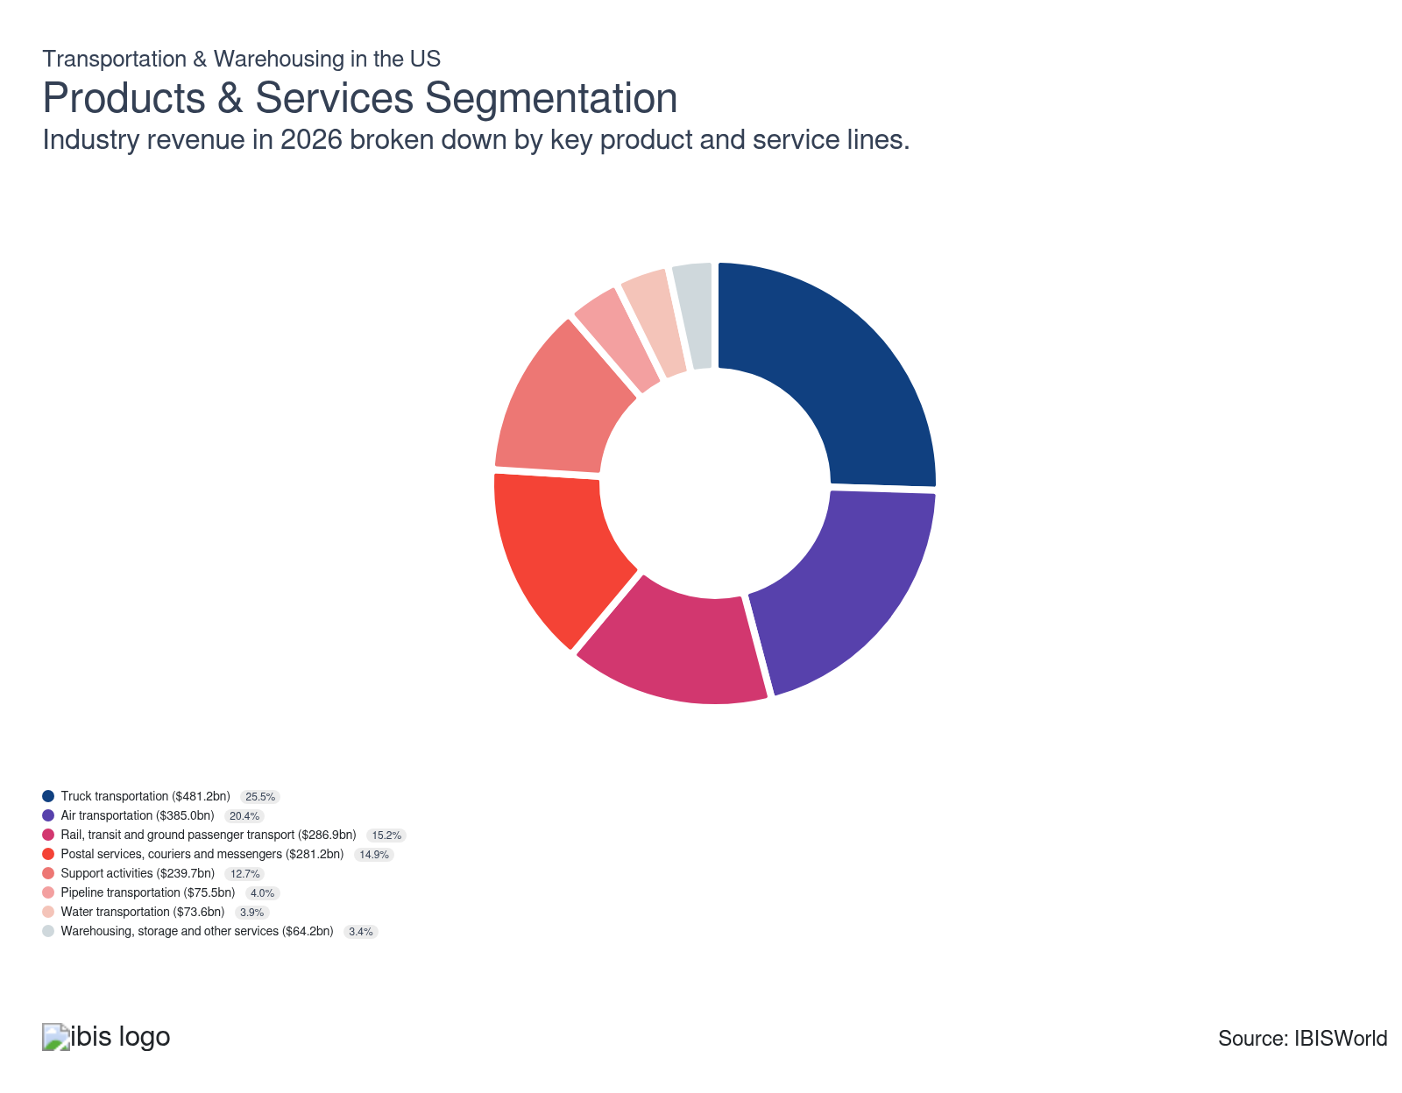

How are the industry’s products and services performing?

Freight recession is constraining truck transport performance
- The truck transportation product segment provides over-the-road movement of goods by trucks and tractor-trailers, spanning local delivery, long-haul moves, general freight and specialized services such as refrigerated or hazardous materials hauling. It commands a large share of transportation and warehousing revenue over the long term because it delivers door-to-door coverage in nearly all US regions, adjusts capacity quickly to shipper demand, and sits at the core of retail, manufacturing, and e-commerce supply chains, where other modes can’t fully substitute.​
- Performance is weak as excess capacity and lower spot rates squeeze operators. A freight recession and oversupply of trucks have pushed down freight rates and reduced segment value, while carrier exits trimmed the number of US long-distance freight trucking companies from 586,301 in 2021 to 580,377 in 2025, signaling a modest contraction in market participation.

Premium passenger demand is driving air transport growth
- The air transportation product segment covers scheduled and charter passenger flights, dedicated air cargo operations, express parcel networks and associated ground handling and airport-based logistics that support aircraft movements. It captures a large share of sector revenue over time because users pay a premium for speed and international connectivity, and passenger airlines bundle fares with ancillary services such as baggage fees, preferred seating and loyalty programs that increase spend per trip.
- Performance is improving as passenger traffic and yield mix strengthen. A recovering travel market and increased spending by higher-income travelers on premium cabins and add-on services like baggage fees are lifting passenger revenue, offsetting soft air cargo performance linked to weaker demand and lower cargo yields, so overall air transport revenue continues to trend upward despite the drag from freight-focused operations.

Coal’s structural decline is weighing on rail performance
- The rail, transit and ground passenger transportation product segment includes intercity and freight railroads, urban transit systems such as buses, light rail and metro services, and ground passenger operators that provide commuter buses, shuttles and taxis on fixed routes or on demand. It holds a moderate share of the sector's revenue over the long term because it provides essential commuting and bulk freight connectivity. Still, growth is limited by public funding cycles, fare regulation, and capital-intensive infrastructure, which constrain commercial pricing flexibility.​
- Performance is weakening in freight rail as coal volumes contract. The Association of American Railroads reported that US coal carloads recorded their 11th monthly decline in December 2024, reflecting reduced coal demand as economies transition away from high-emission fuels, while carloads of other commodities, such as grain and chemicals, showed only a modest rebound.

Mail carrier segments decline as USPS scales back operations
- The delivery services segment, notably the US Postal Service and local delivery companies, handles the distribution of goods across distances, from personal mail to consumer products ordered online. Their historic branding is crucial in connecting consumers and businesses, ensuring efficient delivery.
- USPS has reduced its operational footprint as mail volumes drop, focusing on cost control through workforce reductions, route recalibrations and consolidating facilities. These changes have contributed to lower revenue and limited expansion, decreasing the segment’s presence within logistics.

Lowered freight rates dampening support services performance
- Support services encompass airport operations, aircraft maintenance and repair (MRO) services, harbor and port operations, freight forwarding brokerages and freight packing. These segments are crucial for facilitating the continuous movement and maintenance of vehicles and serve as vital portals for goods entering the country. They represent a significant portion of the transportation and warehousing industry.
- Performance is weak as the freight recession compresses margins and volumes for intermediaries. A steep decline in benchmarks like the Shanghai Containerized Freight Index SCFI has lowered all-in rates for shippers and reduced the spread that freight forwarders and brokers can capture, with UPS reporting large 2024 revenue declines at its Coyote brokerage unit, including a $976.0 million loss tied to softer market rates.

Regulatory index changes are limiting pipeline transport revenue
- The pipeline transportation product segment moves crude oil, natural gas and refined petroleum products through long-distance transmission systems, earning fees for operating, maintaining and monitoring networks rather than handling discrete freight loads. It typically holds a smaller share of sector revenue because earnings are tied to energy throughput and tariff formulas in long-term contracts. Hence, growth stays tied to relatively flat oil and gas output and regulated returns rather than broader freight cycles.​
- Performance is set to soften as tariff escalation slows. The Federal Energy Regulatory Commission FERC has proposed cutting the oil pipeline rate index from PPI for finished goods plus 0.78% to PPI-FG minus 1.42% from July 1, 2026, after a prior attempt to lower the index was vacated by a federal court in 2024, which would materially reduce allowable annual price increases and weigh on pipeline revenue growth.

Warehousing adjusts prices to counter storage costs and improve revenue
- Warehousing and storage services involve holding and handling goods until they’re ready for transport. This is essential in logistics but constrained by time-sensitive turnover. Sightseeing and scenic transportation services, which fall under other services, cater to niche tourist preferences and often don’t attract widespread appeal.
- Over the past five years, this segment increased its market share as warehouses raised prices to cope with rising storage costs. According to Warehousing and Fulfillment, by 2024, 71.7% of companies had implemented price hikes, compared to 69.7% in 2020. This strategy helped alleviate profit erosion from storage costs and boosted market share, showcasing the sector’s adaptability.

Cruise-led leisure demand is supporting water transport performance
- The water transportation services product segment includes ships, barges and boats that move passengers and cargo on oceans, coasts, the Great Lakes and inland waterways, spanning deep-sea container ships, bulk carriers and inland barges. Over the long term, this subsector accounts for a relatively small share of transportation and warehousing revenue because it’s capital-intensive, exposed to volatile global trade flows and constrained by long lead times and port bottlenecks that shift day-to-day logistics spending toward trucking and rail.​
- Performance has improved as cruise activity recovers and expands among higher-income travelers. Rising demand for cruises from wealthier households and families, combined with strong onboard spending, is rebuilding revenue streams for cruise lines and related passenger services, helping the water transportation segment grow even as cargo-focused operators remain more sensitive to swings in global trade volumes.

What are innovations in industry products and services?

Self-driving vehicles revolutionize the transportation industry
- Self-driving vehicles are transforming passenger transport. Waymo recently reached nearly 4.0 million paid trips by 2024, compared to just 700,000 in November 2023, showcasing this technology's rapid growth and importance.
- Transportation companies benefit from this technology by cutting labor costs and honing efficiency with vehicles that don’t require rest, enhancing revenue without employee burnout. A National Association of Realtors survey in 2023 found that 65.0% of respondents preferred living near public transportation, indicating a market for services integrating self-driving cars within public transit-optimized areas.
- Regulatory challenges persist, impacting operational span. In California, agencies like the DMV impose rules restricting the geographical limits of travel to specified cities, such as limiting routes within San Francisco instead of statewide navigation.

Mapping and location data optimize logistics with advanced routing systems
- Logistics operations increasingly rely on mapping and location data systems, with nearly 44.0% of domestic logistics companies adopting these technologies by 2024, according to a survey by HERE and AWS. These systems facilitate long-distance travel by identifying the best possible routes and improving delivery times to meet consumer needs for timely deliveries.
- Despite their effectiveness, implementing these technologies involves challenges. It requires purchasing, delaying profitability as companies incur initial acquisition and installation costs. Employing technicians for on-the-spot errors and necessary repairs because of increased technology use demands higher budgets for workforce spending and maintenance services expertise.

Inventory and network optimization technology drives sector growth
- The sector is adopting inventory and network optimization, featuring management systems that allow companies to monitor their inventory and financial health in real-time. According to a survey by MHI, about 35.0% of companies and related businesses are leveraging this technology as of 2024.
- This innovation aids companies in meeting the need for quick, efficient deliveries and organizing bundled packages and kitting needs. By enhancing order processing, businesses can maintain steady sales. However, implementation isn't immediate and doesn't guarantee increased revenue for all. It requires technical expertise, and transitioning involves data migration and IT upgrades. Integrating these systems will financially impact businesses by necessitating time for training and installation. They must also manage backlogs or errors as teams learn to incorporate these systems into their workflow.

What products or services do successful businesses offer?
Ensure prompt delivery to market
Timely deliveries build customer trust, enhance service reliability and strengthen customer satisfaction, making it a key differentiator in the sector.
Align cost-effective delivery with client needs
Matching efficient delivery solutions with client requirements helps maintain competitiveness while controlling costs, leading to customer satisfaction and operational profitability.

Major Markets
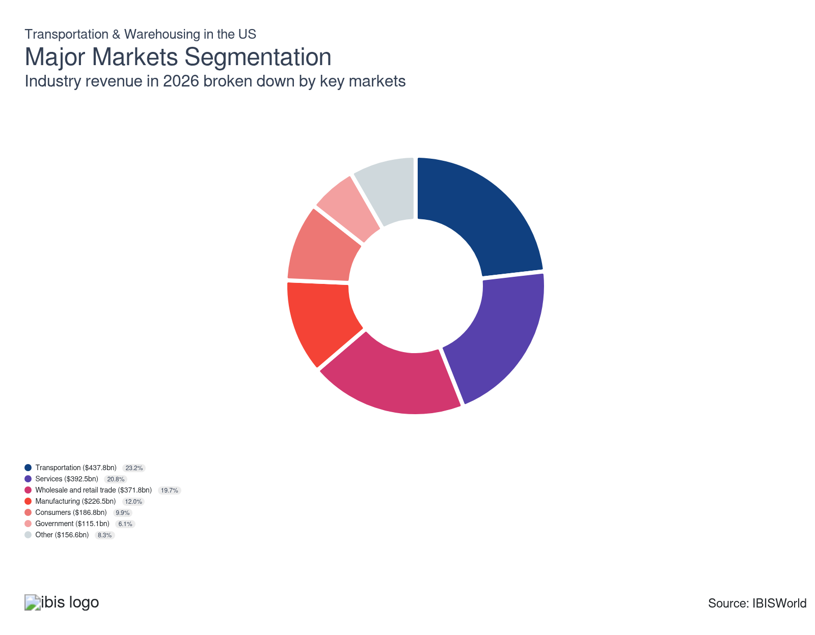

What’s influencing demand from the industry’s markets?

Transportation services support travel-led rebound in demand
- The transportation services market covers moving passengers and freight by road, rail, air, water, transit and pipelines, alongside logistics support such as terminal operations, cargo handling and warehousing that stores and manages inventory between transport legs. Transport activities capture the largest share of revenue over the long term because they sit at critical flow points in supply chains, where customers pay premiums for speed, reliability and network reach across regions.​
- Demand is strengthening as higher-income travelers return to air and cruise travel and allocate more spending to premium trips. Cruise Lines International Association CLIA reported that North American passenger volumes rose 13.4% in 2024 compared with 2023, underscoring robust cruise demand in wealthier markets. AAA indicated that domestic air travel set a record in 2025, with nearly 906.0 million passengers, signalling a broad rebound in US travel that supports revenue growth for transportation service providers.

Healthcare-driven spending is boosting services market demand
- The services markets for the sector include finance, healthcare, professional services, information and government operators that don’t produce physical goods but still require freight, parcel, warehousing and support activities to move people, equipment and high-value items. These markets dominate demand over the long term because the US economy is services-heavy, and cloud data centers, hospitals and consulting projects all rely on background transportation and storage capacity.
- Demand is growing as healthcare spending on specialty drugs increases distribution volumes through wholesalers and logistics providers. The American Society of Health-System Pharmacists ASHP reported that clinic drug spending rose 14.4% in 2024 year over year, while McKesson Corp. reported 21.0% year-over-year revenue growth in the first quarter of fiscal 2025, primarily attributed to higher volumes of GLP-1 and other weight-management drugs, which expand demand for healthcare distribution and related transportation and warehousing services.

Tariffs and weaker imports are softening wholesale and retail demand
- The wholesale and retail trade markets for the sector include merchants and e-commerce retailers that buy freight, parcel, storage and related logistics services to move goods between manufacturers, ports, distribution centers, stores and end customers. These markets are historically the heaviest freight users per dollar of output because long, multi-node supply chains structurally embed trucking, rail and warehousing costs in product distribution.
- Demand is easing as tariffs and weaker import flows limit volumes moving through gateways and domestic networks. In a late-2025 interview with Global Trade Magazine, Vizion CEO Kyle Henderson noted that normalized monthly import volumes remained below 2.0 million twenty-foot equivalent units TEUs, a level last recorded in March 2023, amid softer furniture and toy imports. Descartes Systems Group reported that total US import volumes in 2025 were 0.4% below 2024, reflecting reduced goods flows linked to retail and e-commerce cutbacks that weigh on transportation and warehousing demand from wholesale and retail customers.

Weak US manufacturing output is limiting freight-driven demand
- The manufacturing markets for the sector comprise factories that purchase trucking, rail, port and storage services to move inbound parts and outbound finished goods as embedded components of their supply chains. These customers account for a moderately large revenue share because production networks are geographically dispersed, so even highly automated plants still require frequent, time-sensitive shipments and buffer storage between suppliers, facilities and downstream distributors.
- Demand is under pressure as US manufacturing output contracts and producers adjust to 2025 tariff shocks. Weaker production and slack at domestic facilities have reduced freight volumes. At the same time, FTR vice president of trucking Avery Vise indicated that, although capacity exited the less-than-truckload market into 2025 and supported margins, weak manufacturing output continued to weigh on freight demand and limited the benefit for trucking providers serving industrial customers.

Mail delivery volumes drop as demand for traditional letters continues steady decline, worsening consumer markets
- The consumer market for transportation and warehousing services specializes in directly delivering goods without traditional retail intermediaries. It includes couriers and mail services that individuals depend on to receive or send goods.
- Mail parcel deliveries, especially letters to households, have seen a measurable drop, directly impacting a significant market for services like the Postal Service. USPS Office of Inspector General data show a drop from over 120.0 billion mailpieces in 2020 to 102.0 billion in 2024. This shift highlights how consumer preferences are moving away from traditional mail, resulting in lower volumes and a changed operational landscape for service providers.

Project-based demand from construction and energy markets is steady
- The other market, which includes industries like natural resources, mining, utilities and construction, tends to maintain its market share instead of expanding. This stability reflects the erratic timing of industrial projects affected by economic uncertainties. As the market activity in these sectors remains unchanged, companies are conservative in scaling up their operations.
- Demand from these markets depends on capital spending cycles in infrastructure, energy production and resource development. Periods of higher investment in grid upgrades, pipeline projects, renewable installations, and large-scale construction programs increase the movement of heavy materials and equipment. In contrast, pauses or delays in project pipelines temporarily curtail freight and storage needs.

DoD charter contracts are lifting government transport demand
- The government markets include federal, state and local agencies that purchase freight moves, postal logistics, military and disaster shipments and storage for supplies. This segment accounts for a moderately small share of industry revenue because public entities still operate many functions in-house, such as postal networks, transit fleets and highway operations, and typically use private carriers for specialized or overflow work rather than core day-to-day services.
- Demand is growing for contractors that support defense and emergency logistics. In 2024, the US Department of Defense DoD signed multi-year contracts for international charter airlift services running through September 2026 with at least 30 airlines, including JetBlue and Delta Air Lines, to transport personnel and cargo, increasing the reliance of government agencies on commercial carriers for mission-critical movements.

International Trade

Some industries don't directly import or export goods. See reports at the manufacturing level for international trade data on relevant products.

5. Geographic Breakdown
https://my.ibisworld.com/us/en/industry/48-49/geographic-breakdown

Key Takeaways
- The Southeast is a logistics hotspot thanks to its burgeoning industries. States like Texas and Georgia benefit from their strategic locations with thriving tourist sectors, making them prime business spots.
- Business is booming in the Southwest, especially in Arizona and Oklahoma. Arizona's aerospace hub and Oklahoma's strong infrastructure growth are attracting companies looking to capitalize on lucrative opportunities.

Business Locations
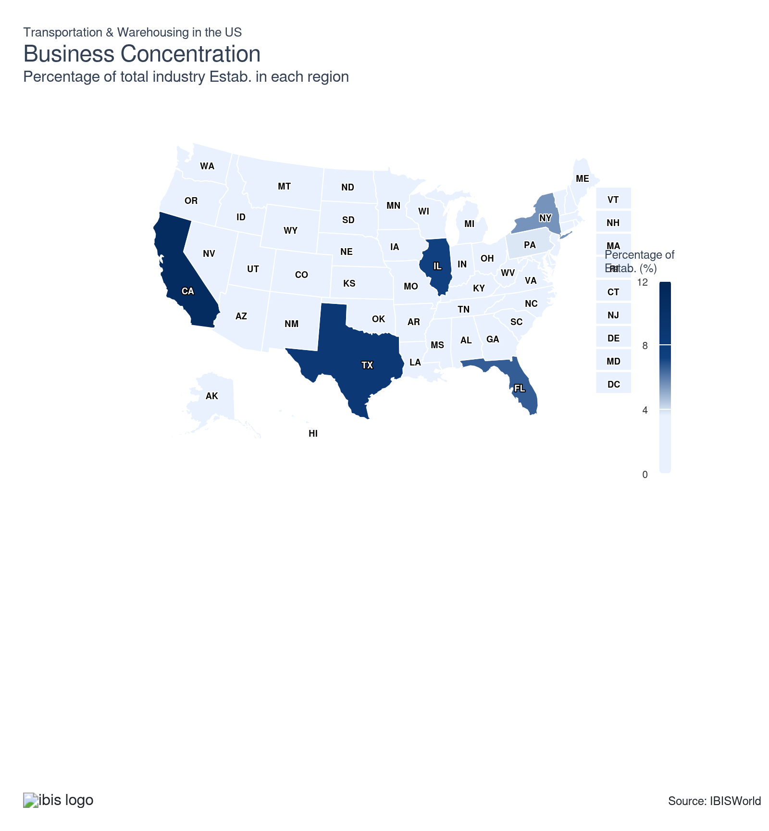
State | Estab.  Units | Estab.  % | Population  %
California | 27193 | 0.5 | 11.5
Texas | 21294 | 0.4 | 9.4
Illinois | 18007 | 0.3 | 3.7
Florida | 16515 | 0.3 | 7.0
New York | 13729 | 0.2 | 5.8
Pennsylvania | 9387 | 0.2 | 3.8
New Jersey | 7900 | 0.1 | 2.8
Ohio | 8051 | 0.1 | 3.5
Georgia | 7430 | 0.1 | 3.3
Michigan | 7026 | 0.1 | 3.0
North Carolina | 6509 | 0.1 | 3.3
Washington | 5885 | 0.1 | 2.3
Wisconsin | 5752 | 0.1 | 1.7
Indiana | 5602 | 0.1 | 2.0
Virginia | 5353 | 0.1 | 2.6
Minnesota | 4983 | 0.1 | 1.7
Missouri | 5047 | 0.1 | 1.8
Tennessee | 4566 | 0.1 | 2.1
Massachusetts | 4131 | 0.1 | 2.1
Colorado | 4030 | 0.1 | 1.8
Iowa | 3863 | 0.1 | 0.9
Louisiana | 3729 | 0.1 | 1.3
Arizona | 3623 | 0.1 | 2.2
Maryland | 3542 | 0.1 | 1.8
Oregon | 3294 | 0.1 | 1.2
Kentucky | 2991 | 0.1 | 1.3
South Carolina | 2896 | 0.1 | 1.6
Alabama | 3173 | 0.1 | 1.5
Oklahoma | 2792 | 0.1 | 1.2
Arkansas | 2465 | 0.0 | 0.9
Kansas | 2615 | 0.0 | 0.9
Nebraska | 2477 | 0.0 | 0.6
Utah | 2496 | 0.0 | 1.0
Mississippi | 2200 | 0.0 | 0.9
Idaho | 1894 | 0.0 | 0.6
Connecticut | 1707 | 0.0 | 1.1
Nevada | 1811 | 0.0 | 1.0
Montana | 1399 | 0.0 | 0.3
New Mexico | 1446 | 0.0 | 0.6
North Dakota | 1500 | 0.0 | 0.2
Alaska | 1182 | 0.0 | 0.2
Maine | 1243 | 0.0 | 0.4
South Dakota | 1275 | 0.0 | 0.3
West Virginia | 1178 | 0.0 | 0.5
Hawaii | 966 | 0.0 | 0.4
Wyoming | 965 | 0.0 | 0.2
Delaware | 761 | 0.0 | 0.3
New Hampshire | 831 | 0.0 | 0.4
Rhode Island | 728 | 0.0 | 0.3
Vermont | 474 | 0.0 | 0.2
District of Columbia | 174 | 0.0 | 0.2

Where are industry businesses located?

Activity is booming in the Southeast
- The Southeast leads in the number of sector locations because of its diverse industries, such as construction, manufacturing and energy. States such as Texas and Georgia benefit from large populations and significant tourism industries, which draw logistical companies aiming to streamline operations near busy transportation hubs.
- Cities such as Atlanta, GA, are attractive to transportation businesses because of their population and tourist activities. The state's primary international airport and extensive interstate highways make it an ideal spot for logistical companies looking to capitalize on high traffic volumes.
- The construction market in North Carolina, particularly in Charlotte, is flourishing, attracting numerous transportation and warehousing businesses. Offering a corporate tax rate of just 2.5%, the lowest in the United States, North Carolina is an attractive location for business investments. According to the North Carolina Economic Activity Report, foreign direct investment projects in the state amounted to $7.9 billion in 2024, up from $1.8 billion in 2023. This economic growth creates a supportive atmosphere for logistics operations drawn in by space availability and financial incentives.

Logistical businesses gravitate to emerging western states
- The economic vitality in western states such as California, Nevada and Washington is drawing transportation and warehousing businesses. California has significant ports in cities like Oakland and Los Angeles, which support extensive import-export activities. Nevada and Washington are gaining attention because of their burgeoning tourism industries, notably Las Vegas and Seattle. Beyond tourism, these states are experiencing growth across various industry sectors, boosting the need for logistics services.
- Nevada has emerged as a rising logistics state, with its location within a one-day truck drive of nearly seven states, including California and Utah, making it a central node for faster deliveries. The state is attracting network reconfiguration: Amazon closed a Reno fulfillment center in August 2025 to build a same-day delivery facility through 2026, and MD Logistics shifted its West Coast distribution operations to Reno to avoid California emissions regulations, signaling Nevada’s appeal as a lower-cost, growth-oriented base for warehousing and distribution.
- Washington is also developing into a key logistics growth market, supported by deepwater port access and proximity to major trade lanes. The expansion of 24-hour delivery models has encouraged investments, such as AFCO Distribution & Milling’s new distribution location in Lacey in August 2025, which leverages the I-5 corridor’s links to California and Canada. Rising agricultural and manufacturing activity is increasing the state’s freight potential, while geographic dispersion is pushing policymakers and operators to build new inland connectivity. In 2026, the Northwest Seaport Alliance and the ports of Benton, Pasco and Walla Walla signed an interlocal agreement to create an inland logistics hub, aiming to improve access for regional shippers and strengthen Washington’s role in domestic and international trade flows.

Businesses thrive in the Southwest region
- The Southwest region, including Arizona and Oklahoma, is experiencing significant growth in transportation and warehousing businesses. Arizona, in particular, has become a hub for aerospace and defense companies. The state is home to numerous air force bases, making it an attractive location for these companies to secure lucrative government contracts. As of 2023, nearly 7.6% of the nation's aerospace and defense workforce is based in Arizona, according to the Aerospace Industries Association. This concentration of industry prompts increased logistics activities to meet market activity efficiently.
- Conversely, Oklahoma has become a key player in the logistics sector thanks to its thriving Maintenance, Repair and Overhaul (MRO) services. The state's facilities often cater to aircraft repair needs, requiring high-volume and efficient goods delivery. Oklahoma introduced the Supporting Industrial Transformation and Economic Success Ready Program to strengthen its economy, which secured $178.0 million for infrastructure improvements, as noted by its Commerce Department in 2024.
- Enhancements in infrastructure have elevated Oklahoma's status as a transportation hub. This status attracts more freight delivery companies to establish their base in Oklahoma. For example, large projects like the Legends Tower in Oklahoma City draw construction businesses that require efficient logistics for transporting building materials. Because of these developments, Oklahoma remains a key location for transportation and warehousing businesses.
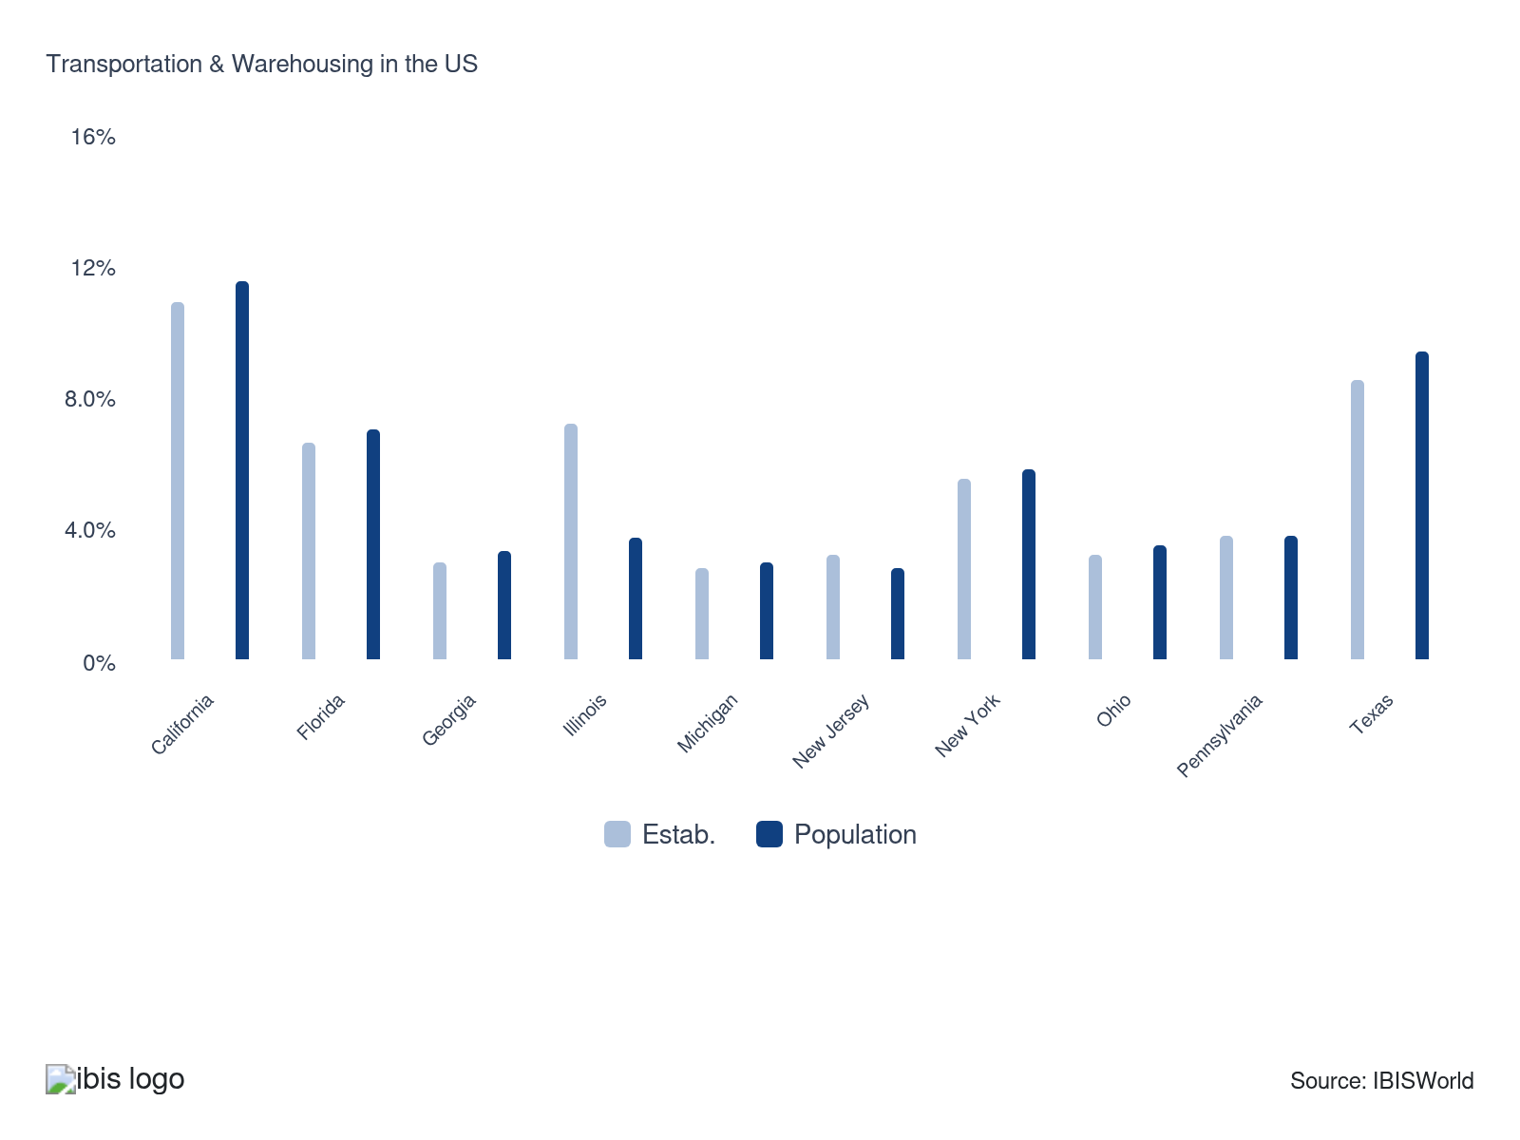

How do businesses use location to their advantage?
Attract local support
A steady supply of employees must exist in every region to ensure that different services are carried out effectively in each state, town, county and neighborhood.
Develop an extensive distribution network
Having an extensive distribution network nationwide benefits providers by allowing them to capture maximum market activity from booming sectors like construction or manufacturing in active regions.

6. Competitive Forces
https://my.ibisworld.com/us/en/industry/48-49/competitive-forces

Key Takeaways
- Big retailers like Walmart are building internal logistics networks to cut costs and boost competitiveness. By reducing reliance on third-party services, they can manage operations independently and potentially see substantial savings.
- High start-up costs deter new competitors, who must invest heavily in an extensive fleet and facilities. This substantial initial expense requires immediate returns to avoid succumbing to current rivals, thereby elevating their operational challenges.

Concentration
Low
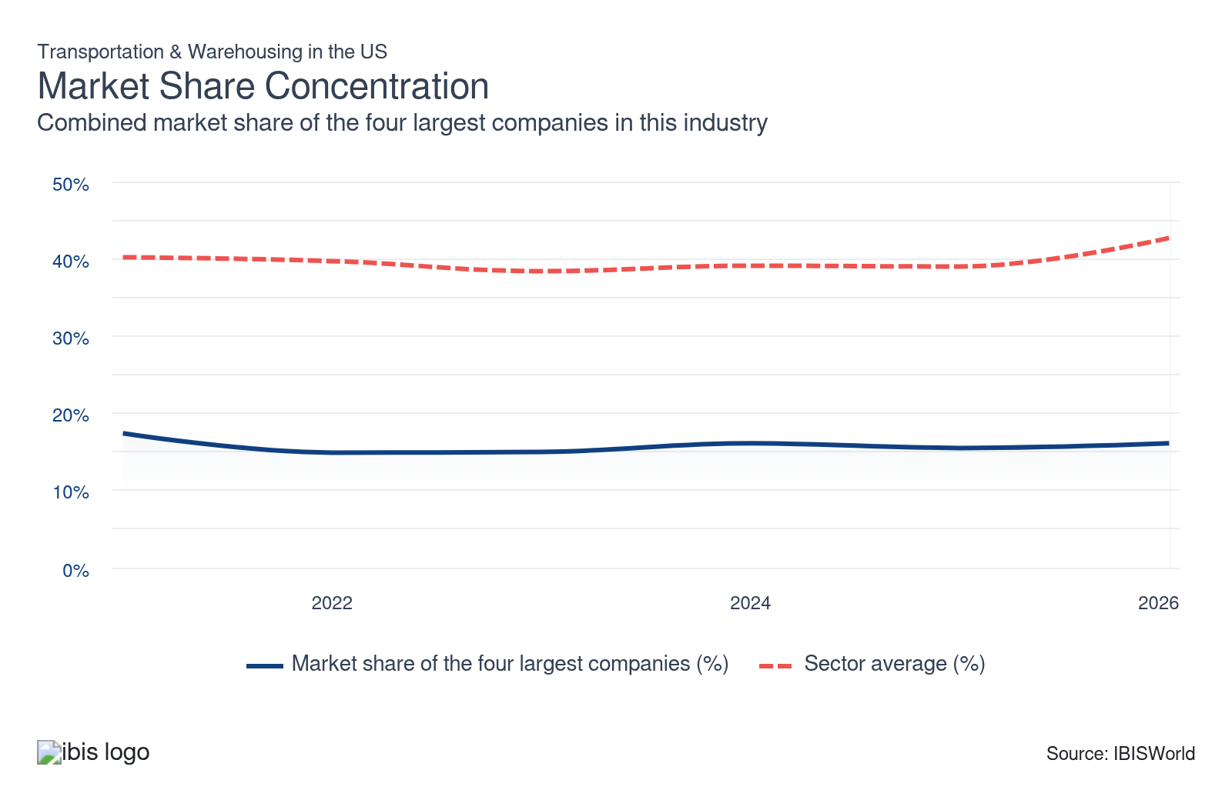

What impacts the industry’s market share concentration?

High acquisition costs restrict market share concentration
- In recent years, companies have increasingly outsourced domestic transportation for cost efficiency, with nearly 50.0% of shippers doing so by 2024, according to NTT Data. This trend has elevated market valuations, raising the median asking price for truck transportation companies to $1.0 million in 2024, up from $762,500 four years earlier, as per BizBuySell data.
- The elevated prices result in moderated mergers and acquisitions because companies must invest more capital to acquire these expensive entities. High costs stagnate potential consolidation efforts and lower concentration in the market. Despite the lucrative potential, some companies might adjust strategies or explore alternative practices when assessing their portfolios or expansion plans within the warehouse transportation sector.

Market instability drives legacy transportation companies to limit expansion
- Changes in freight activity influence company valuations, putting older companies at a disadvantage during this period of logistical improvement. According to Motive data, older companies made up 50.0% of market exits in 2024, up from 37.0% in 2023, highlighting these challenges.
- As the economy stabilizes, businesses focus more on financial stability than expansion. Major companies such as UPS are making strategic decisions, like selling their Coyote Logistics to offset reduced operating profit in 2024. This decision highlights a broader shift toward financial consolidation, where cutting excess expenditures and maintaining existing operations are prioritized to sustain market shares.

Antitrust constraints limit market share expansion in the transportation industry
- Antitrust regulations restrict the expansion of the airline industry by limiting mergers that lead to high market share concentration. Between 2020 and 2024, data from Airlines for America indicated that only three domestic airline acquisitions occurred. These regulations aim to protect consumers, but they pose challenges for larger companies trying to consolidate and enhance their competitive abilities in the face of increasing operational demands. Airlines must be cautious in their expansion efforts to avoid raising federal antitrust issues.
- Merger and acquisition attempts face significant hurdles, as evidenced by the blocked JetBlue and Spirit Airlines merger deal in 2024. The Department of Justice and federal courts intervened, citing concerns that market concentration would boost ticket prices. Such regulatory pushback highlights airlines' difficulty in expanding their operations through partnerships.

How do successful businesses handle concentration?
Develop a strong reputation
Reputation helps make companies stand out more in a competitive field. Many industries have a significant major player presence, so differentiating services and offering competitive pricing can set new entrants apart from household names.
Carrying out all necessary maintenance to keep facilities in good condition
Ensuring facilities are in good shape demonstrates a commitment to safety and security. Some industries are stricter than others. Smaller companies that maintain facilities in good condition build their reputations and gain steady revenue streams, helping them compete effectively with major companies.

Barriers to Entry
Moderate | Steady

What challenges do potential industry entrants face?

Legal
- Government regulation becomes more stringent based on the riskiness of cargo and its related transport. For example, airline and pipeline regulation is robust because aircraft failure could lead to mass fatalities and oil spills can cause large-scale environmental damage. Some municipalities even charge a high cost and enforce strict requirements for taxi medallions and licenses.

Start-up Costs
- High start-up costs present a significant challenge for new entrants in the sector. Extensive warehouse facilities and a fleet of vehicles are essential, leading to substantial initial expenses. Such barriers discourage new competitors from entering the market as they struggle to match local rivals and establish a foothold in any logistics industry.

Differentiation
- Differentiation is a concern, depending on the industry. In freight forwarding, characterized by diverse companies and minimal single-company dominance, opportunities abound through localized knowledge and cost strategies. In contrast, entrenched brands like FedEx and USPS make penetrating local delivery markets particularly tough, given their widespread recognition and defined services.

Capital Expenses
- Potential entrants in the sector face high capital expenditures. Large investments in buildings, equipment and machinery are essential. Trucking sectors, in particular, must quickly assemble an operational fleet to compete effectively. Established entities have already made such investments, putting pressure on new entities to match these initial costs rapidly.

How can potential entrants overcome barriers to entry?
Ability to accommodate environmental requirements
Entrants must adapt to environmental requirements for the sector's continued viability. The most environmentally friendly providers gain a stable revenue stream from pollution-conscious consumers, reducing differentiation and hindering barriers to entry.
Compete on tender
The ability to tender competitively for contracts and complete the job within budget is a characteristic of successful companies within the sector. Having these offers also helps companies differentiate themselves, reducing barriers to entry.

Substitutes
Low | Steady

What are substitutes for industry services?

In House
- Certain retailers are increasingly developing their internal logistics networks as alternatives to traditional transportation and warehousing services, aiming to enhance cost efficiency and competitiveness. For example, retail giant Walmart operates an extensive logistics network comprising 162 distribution facilities, per its 2023 annual report. By doing so, Walmart reduces its dependency on third-party logistics providers, decreasing its need for traditional warehousing services. This strategic move allows these corporations to manage their operations independently.
- In the third quarter of 2024, Walmart achieved a 40.0% reduction in the cost per order and observed a 20.0% gain in orders delivered per store. These improvements highlight the benefits of automation and enhanced logistics. As one of the largest retailers in the US, Walmart's strategic move may signal a significant shift in the retail industry, encouraging other businesses to consider developing their own logistics solutions to stay competitive and reduce dependency on external logistical services.

How do successful businesses compete with substitutes?
Invest in new technology to enhance operational efficiency and quality
Using state-of-the-art technologies enables the sector to optimize processes, reduce costs and improve service quality. This technological edge makes it harder for substitutes to compete on efficiency and reliability.
Offer a range of home delivery options
Providing multiple home delivery options improves customer satisfaction and convenience, which are key differentiators in combating substitute competition. Tailoring delivery services to meet varied customer needs builds loyalty and reduces the likelihood of customers seeking alternatives.

Buyer & Supplier Power
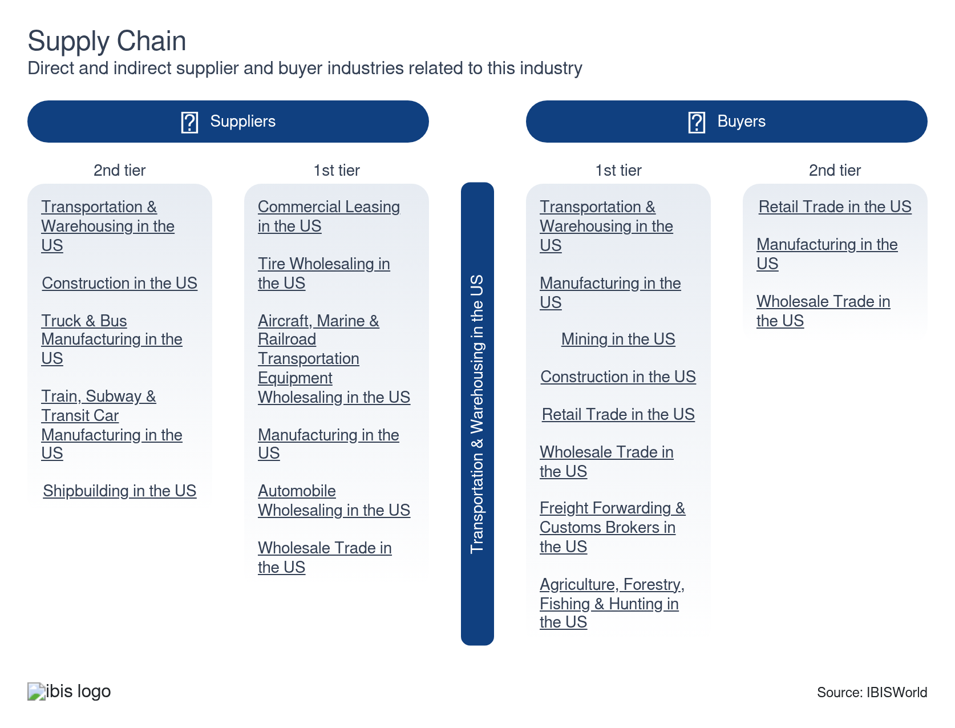

What power do buyers and suppliers have over the industry?

Buyers: Holding sway in logistics negotiations
High | Increasing
- Buyers exert significant leverage in the sector because of the undifferentiated nature of logistical services, which perform similar functions such as transporting goods or passengers to designated destinations. Since these services offer virtually the same operations, buyers can choose providers based on personal preferences, influencing service provision choices and terms.
- Major sectors, like manufacturing, rely heavily on logistical services, giving them added bargaining strength. Buyers can leverage the size and location of their operations in negotiations, dictating terms and influencing deals based on the volume of goods transported. Large-volume buyers can negotiate favorable contracts or opt to diversify services across providers.

Suppliers: Premium property locations drive leasing power
Moderate | Steady
- Supplier power in the sector is moderate, primarily because of the control held by commercial leasing entities over high-value properties. They command top lease prices for locations near high business activity, driving supplier power. However, the low concentration of commercial leasing companies tempers their influence. Regions ranging from the Southeast to the West are seeing considerable growth opportunities, which disperses supplier control and reduces the dominance of any single leasing company.
- Leasing companies offer contract concessions to retain clients in a competitive market. As nearby facilities present customization opportunities, businesses are positioned advantageously close to transportation and logistics expansion benefits.

How do successful businesses manage buyer & supplier power?
Automate processes to reduce costs
Automation helps companies cut costs and weakens buyer power by improving operations. Boosting their efficiencies makes it harder for buyers to influence deals and tough for competitors to match. Because of this, buyers often end up relying on these efficient companies.
Continue paying suppliers during economic downturn
Upstream suppliers must get paid to keep operations flowing in nearly every industry in this sector, keeping supplier power lower as it retains reliable outlets for their operations so they won't be under the whims of untrustworthy suppliers that lack a relationship.

7. Companies
https://my.ibisworld.com/us/en/industry/48-49/companies

Key Takeaways
- The sector has a large and growing number of independent providers across numerous industries. The diverse range of available modes of transport makes it very difficult for any one company to dominate on a sector level.
- The United States Postal Service (USPS) is a major player. The agency generates billions of dollars in revenue and employs more than half a million Americans.

Market Share
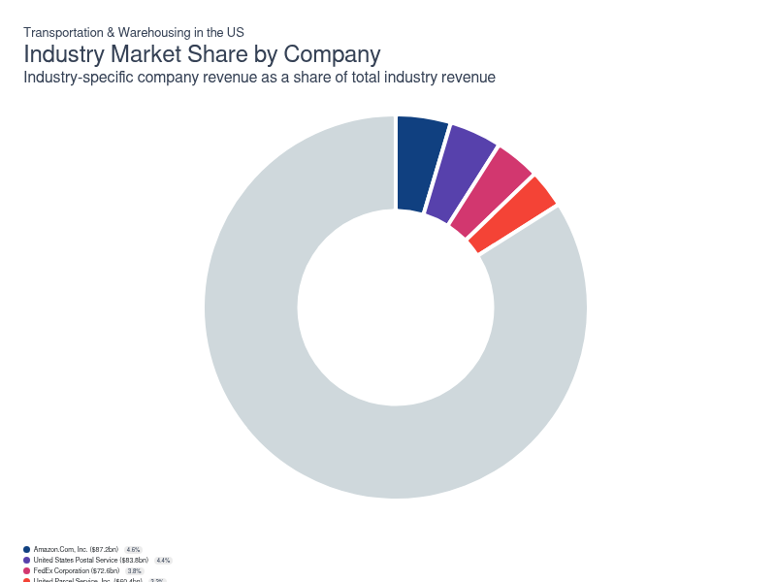
Chart displays current year only in the PDF version of this report. You can view and download chart for all other years associated with this industry on my.ibisworld.com.

Companies
Company | Market Share (%)  2026 | Revenue ($m)  2026 | Profit ($m)  2026 | Profit Margin (%)  2026
Amazon.Com, Inc. | 4.6 | 87,245.0 | 10,239.1 | 11.7
United States Postal Service | 4.4 | 83,800.0 | -8,100.0 | -9.7
FedEx Corporation | 3.8 | 72,594.1 | 4,739.8 | 6.5
United Parcel Service, Inc. | 3.2 | 60,426.7 | 5,395.0 | 8.9

Amazon.Com, Inc.
Amazon.Com, Inc.
Company Details
Company Details
Industry Specific Revenue (2026) | $87.2bn
Industry Profit (2026) | $10.2bn
Company Employees (2026) | 1,576,000
Market Share (2026) | 4.6%

Description
Description
Amazon.Com is a public company headquartered in Washington with an estimated 1,576,000 employees. In the US, the company has a notable market share in at least 34 industries: Online Computer & Tablet Sales, Online Small Electrical Appliance Sales, Online Grocery Sales, Online Pet Food & Pet Supply Sales, Online Perfume & Cosmetic Sales, Online Vitamin & Supplement Sales, Online Shoe Sales, Online Men's Clothing Sales, Online Women's Clothing Sales, Online Jewelry & Watch Sales, Online Book Sales, Online Children's Toy Sales, Online Hobby & Craft Supplies Sales, Online Office & School Supply Sales, Digital Music Downloads, Online Video Downloads, Online Computer Software Sales, Third-Party Logistics, Online Baby Product Sales, Internet Hosting Services, Cloud Security Software, Business Intelligence Software, Music Streaming Services, Video Streaming Services, Hyperscale Data Center Services, Transportation & Warehousing, Data Processing & Hosting Services, Database, Storage & Backup Software Publishing, Electronics & Appliance Retailing, Hiking & Outdoor Equipment Stores, Speech & Voice Recognition Software Developers, E-book Publishing, Online Home Furnishings Sales, Online Hardware & Tool Sales and Speech & Voice Recognition Software Developers. Their largest market share is in the Online Book Sales industry, where they account for an estimated 58.6% of total industry revenue and are considered a Rising Star because they display lower market share, but displaying stronger profit and revenue growth than some of their peers.

Brands and Trading Names
Brands and Trading Names
- 6pm.com
- Amazon Books
- Amazon Studios
- Amazon.com
- AmazonFresh
- AWS
- EastDane.com
- Ring
- Twitch
- Woot.com
- Zappos.com

Other Industries
Other Industries
- Business Intelligence Software in the US
- Cloud Security Software in the US
- Data Processing & Hosting Services in the US
- Database, Storage & Backup Software Publishing in the US
- E-book Publishing in the US
- Internet Hosting Services in the US
- Music Streaming Services in the US
- Online Baby Product Sales in the US
- Online Book Sales in the US
- Online Children's Toy Sales in the US
- Online Computer & Tablet Sales in the US
- Online Computer Software Sales in the US
- Online Grocery Sales in the US
- Online Hardware & Tool Sales in the US
- Online Hobby & Craft Supplies Sales in the US
- Online Home Furnishings Sales in the US
- Online Jewelry & Watch Sales in the US
- Online Men's Clothing Sales in the US
- Online Office & School Supply Sales in the US
- Online Perfume & Cosmetic Sales in the US
- Online Pet Food & Pet Supply Sales in the US
- Online Shoe Sales in the US
- Online Small Electrical Appliance Sales in the US
- Online Video Downloads in the US
- Online Vitamin & Supplement Sales in the US
- Online Women's Clothing Sales in the US
- Speech & Voice Recognition Software Developers in the US
- Third-Party Logistics in the US
- Video Streaming Services in the US

Company’s Industry Revenue, Market Share, and Profit Margin Over Time
Company’s Industry Revenue, Market Share, and Profit Margin Over Time
Year | Industry Revenue ($ million) | Market Share (%) | Profit Margin (%)
2021 | 53940 | 3.7 | 5.3
2022 | 56789 | 3.2 | 2.4
2023 | 64226 | 3.6 | 6.4
2024 | 86171 | 4.8 | 10.8
2025 | 78456 | 4.2 | 10.4
2026 | 87245 | 4.6 | 11.7

United States Postal Service
United States Postal Service
Company Details
Company Details
Industry Specific Revenue (2026) | $83.8bn
Industry Profit (2026) | -$8.1bn
Company Employees (2026) | 635,000
Market Share (2026) | 4.4%

Description
Description
United States Postal Service is a public company headquartered in District of Columbia with an estimated 635,000 employees. In the US, the company has a notable market share in at least two industries: Transportation & Warehousing, Postal Service and Transportation & Warehousing. Their largest market share is in the Postal Service industry, where they account for an estimated 117.2% of total industry revenue and are considered a Laggard because they display lower market share alongside slower profit and revenue growth than their peers.

Brands and Trading Names
Brands and Trading Names
- USPS

Other Industries
Other Industries
- Postal Service in the US

Company’s Industry Revenue, Market Share, and Profit Margin Over Time
Company’s Industry Revenue, Market Share, and Profit Margin Over Time
Year | Industry Revenue ($ million) | Market Share (%) | Profit Margin (%)
2018 | 70660 | 5.3 | -5.4
2019 | 71306 | 5.1 | -12.4
2020 | 13339 | 1.1 | -12.5
2021 | 77069 | 5.2 | -6.4
2022 | 78812 | 4.4 | 71.1
2023 | 79324 | 4.4 | -8.2
2024 | 80505 | 4.5 | -11.8
2025 | 81352 | 4.4 | -11.0
2026 | 83800 | 4.4 | -9.7

What's impacting United States Postal Service's performance?

USPS Overhauls Delivery Standards and Network in 2024 Amid Mounting Financial Losses
- In 2024, the United States Postal Service (USPS) initiated significant operational changes in response to ongoing financial losses and shifting mail volumes. The agency shifted its service standards from the 3-digit ZIP code system to a more precise 5-digit ZIP code model; under these new standards, pick-up and drop-off of mail at post offices distant from regional processing hubs will now primarily take place in the morning, a move aimed at minimizing transport costs. USPS is also expanding its transportation networks to support longer delivery distances under shorter timelines. These initiatives fall under the “Delivering for America” plan, which seeks to streamline mail and package operations while maintaining six-day service and existing post office hours. According to former Postmaster General Louis DeJoy, approximately half of the agency’s delivery routes are operating at a loss, making greater efficiency and cost containment urgent priorities as USPS adapts to evolving consumer behaviors and mounting financial pressures.

USPS Plans Price Increase because of APWU Wage Adjustments
- The USPS is under financial pressure because of its partnership with the American Postal Workers Union (APWU), which negotiates employee wages through Cost of Living Adjustments (COLA). Under the 2021 agreement, these COLA increases will add $6,302 annually per employee from 2021 to 2024. Because of this, the USPS's operating costs were significantly impacted. To manage this, the USPS has proposed a 3.2% price hike for Priority Mail and Express services in 2025. This price adjustment is part of USPS's strategy to counterbalance the rising labor costs in a challenging financial environment.

USPS Allocates Inflation Reduction Act Funds for EV Infrastructure, Targets 800 Charging Sites by 2028
- The US Postal Service is expanding its electrified vehicle (EV) charging network with financial support from the Inflation Reduction Act, which committed nearly $3 billion through 2031 for vehicle purchase and infrastructure upgrades. As of 2024, USPS has spent at least $112.3 million from these funds, focusing chiefly on upgrading technological infrastructure and building EV-related facilities. Spending on electric vehicles has so far come from the agency's operational revenue rather than federal dollars. USPS aims to equip 800 locations with EV charging stations by 2028, enabling the integration of 66,000 battery electric vehicles into its delivery fleet. Although early investments center on charging infrastructure, the agency's long-term strategy is to significantly scale its EV fleet and related support systems over the coming years.
FedEx Corporation
FedEx Corporation
Company Details
Company Details
Industry Specific Revenue (2026) | $72.6bn
Industry Profit (2026) | $4.7bn
Company Employees (2026) | 510,000
Market Share (2026) | 3.8%

Description
Description
FedEx is a public company headquartered in Tennessee with an estimated 510,000 employees. In the US, the company has a notable market share in at least five industries: Transportation & Warehousing, Business Service Centers, Couriers & Local Delivery Services, Product Return Management Services, General Freight Trucking (Less Than Truckload) and Transportation & Warehousing. Their largest market share is in the Couriers & Local Delivery Services industry, where they account for an estimated 36.7% of total industry revenue and are considered an All Star because they display stronger market share, profit and revenue growth compared to their peers.

Brands and Trading Names
Brands and Trading Names
- FedEx Express
- FedEx Freight
- FedEx Ground
- FedEx Logistics
- FedEx Office
- FedEx Services

Other Industries
Other Industries
- Business Service Centers in the US
- Couriers & Local Delivery Services in the US
- General Freight Trucking (Less Than Truckload) in the US
- Product Return Management Services in the US

Company’s Industry Revenue, Market Share, and Profit Margin Over Time
Company’s Industry Revenue, Market Share, and Profit Margin Over Time
Year | Industry Revenue ($ million) | Market Share (%) | Profit Margin (%)
2016 | 39187 | 3.4 | 7.6
2017 | 42482 | 3.5 | 6.5
2018 | 46429 | 3.5 | 6.4
2019 | 48404 | 3.5 | 3.5
2020 | 58792 | 4.7 | 7.0
2021 | 64941 | 4.4 | 6.7
2022 | 64890 | 3.7 | 5.4
2023 | 63531 | 3.6 | 6.3
2024 | 62916 | 3.5 | 5.9
2025 | 68966 | 3.7 | 6.8
2026 | 72594 | 3.8 | 6.5

What's impacting FedEx Corporation's performance?

CNBC mentions FedEx is a target for activist takeover
- FedEx was mentioned in a CNBC news article on March 8th 2022 as an easy target for activist takeover. This opinion was made based on market cap analysis of FedEx versus UPS, its closest competitor; FedEx has a market cap on $53 billion while rival UPS has a market cap three times higher at over $175 billion. FedEx is net to report its Q3 results in less than a week.

FedEx buys RouteSmart as global transportation M&A activity increases
- A report by PWC highlights a significant boost in mergers and acquisitions within the international transportation and logistics sector. In the six months leading up to November 2024, deals climbed to $51.5 billion, up from $39.5 billion in the preceding six months. This surge suggests increasing corporate efforts to expand market value amid fierce competition. Reflecting this trend, FedEx acquired RouteSmart Technologies in February 2025. RouteSmart specializes in route optimization through its RaaS method, aligning well with FedEx's strategy to bolster its service capabilities and market standing.
United Parcel Service, Inc.
United Parcel Service, Inc.
Company Details
Company Details
Industry Specific Revenue (2026) | $60.4bn
Industry Profit (2026) | $5.4bn
Company Employees (2026) | 490,000
Market Share (2026) | 3.2%

Description
Description
United Parcel Service is a public company headquartered in Georgia with an estimated 490,000 employees. In the US, the company has a notable market share in at least five industries: Transportation & Warehousing, Freight Forwarding & Customs Brokers, Business Service Centers, Couriers & Local Delivery Services, Third-Party Logistics and Transportation & Warehousing. Their largest market share is in the Couriers & Local Delivery Services industry, where they account for an estimated 31.5% of total industry revenue.

Brands and Trading Names
Brands and Trading Names
- UPS

Other Industries
Other Industries
- Business Service Centers in the US
- Couriers & Local Delivery Services in the US
- Freight Forwarding & Customs Brokers in the US
- Third-Party Logistics in the US

Company’s Industry Revenue, Market Share, and Profit Margin Over Time
Company’s Industry Revenue, Market Share, and Profit Margin Over Time
Year | Industry Revenue ($ million) | Market Share (%) | Profit Margin (%)
2008 | 37907 | 4.0 | 9.0
2009 | 33219 | 4.0 | 9.0
2010 | 35867 | 4.0 | 9.0
2011 | 38913 | 4.0 | 9.0
2012 | 40700 | 4.0 | 9.0
2013 | 42303 | 4.0 | 9.0
2014 | 45166 | 4.1 | 9.0
2015 | 45885 | 4.1 | 9.0
2016 | 46267 | 4.1 | 9.0
2017 | 49639 | 4.1 | 11.5
2018 | 53416 | 4.0 | 7.7
2019 | 46493 | 3.4 | 10.5
2020 | 53499 | 4.3 | 9.1
2021 | 60317 | 4.1 | 13.2
2022 | 64611 | 3.6 | 13.0
2023 | 60205 | 3.4 | 10.0
2024 | 60376 | 3.3 | 9.3
2025 | 59954 | 3.2 | 9.1
2026 | 60427 | 3.2 | 8.9

What's impacting United Parcel Service, Inc.'s performance?

Air Cargo Activity Fuels 2024 UPS-USPS Partnership to Enhance Logistics
- In 2024, air cargo services experienced significant growth. The International Air Transport Association (IATA) reported a 3.7% climb in global capacity compared to December 2023 and a 6.1% boost in market activity. This dynamic environment is reshaping business operations, with UPS becoming the leading air cargo partner for USPS early in the year. This strategic partnership enables both companies to meet better increasing consumer expectations and enhance their competitiveness in the market.

You can view and download company details on my.ibisworld.com.

8. External Environment
https://my.ibisworld.com/us/en/industry/48-49/external-environment

Key Takeaways
- Trucking companies are leery about FMCSA's stricter drug policies. With drivers linked to failed drug or alcohol tests barred from commercial driving licenses, finding qualified personnel quickly just got tougher.
- The federal government’s funding boost is a big win for the aviation workforce. With $60.0 million set aside annually until 2028, the Aviation Workforce Development Grant Program lightens the burden for airlines by covering essential training gaps.

External Drivers

What demographic and macroeconomic factors impact the industry?
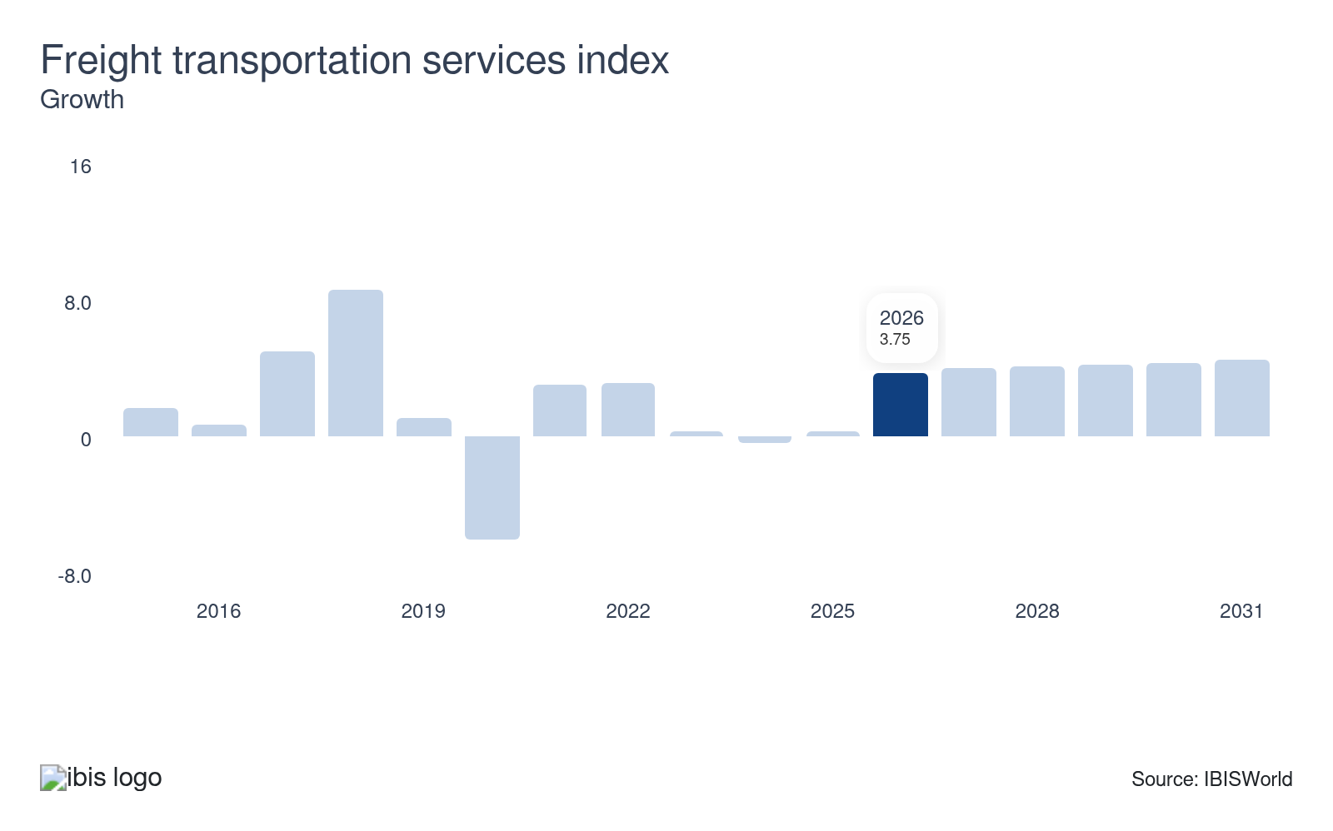
The freight transportation services index monitors the sector’s activities, tracking freight weight across trucking, railroads, inland waterways, pipelines and air freight carriers. More freight signals a higher need for these services, presenting growth opportunities for the sector. Conversely, a drop in the index indicates a reduced need for their services.
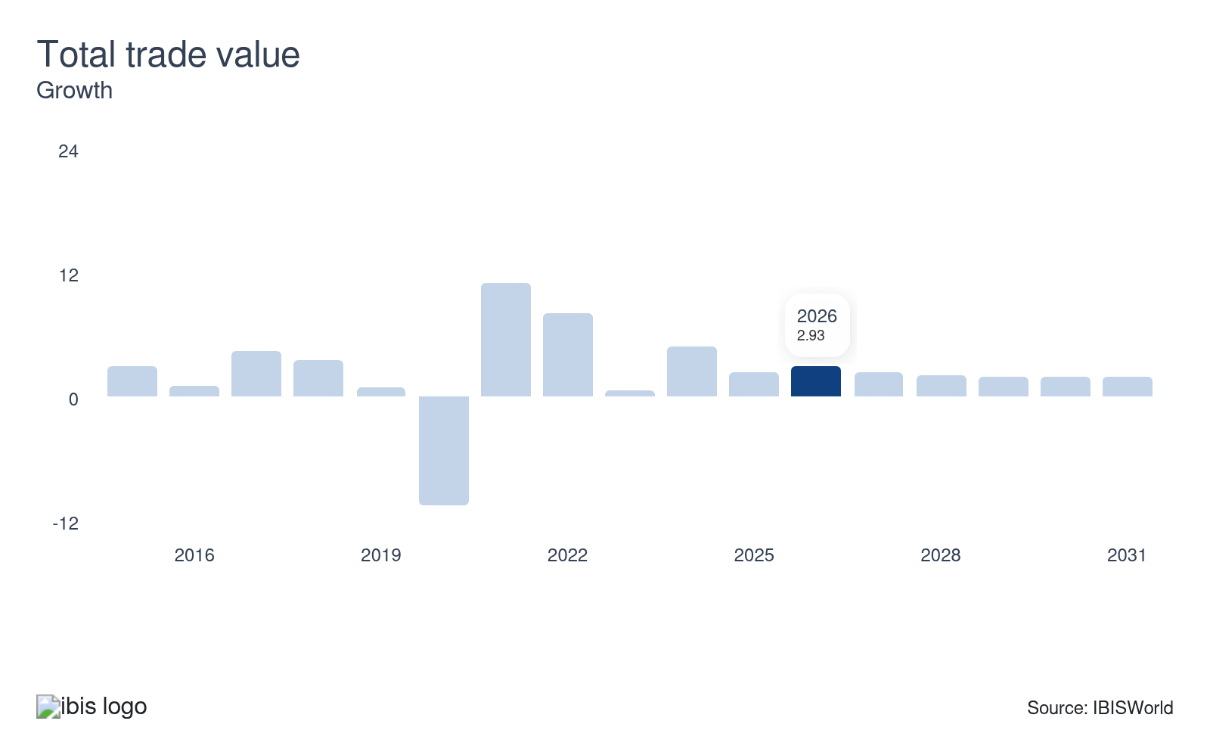
Although not directly engaged in trade, this sector relies on it for its operations. It delivers essential services like trucking, water transport and infrastructure such as ports and warehouses, which are vital for importing and exporting goods, making this a potential opportunity. Since the sector's activity level depends on trade volume, a drop reduces the quantity of goods transported, impacting its economic stability.
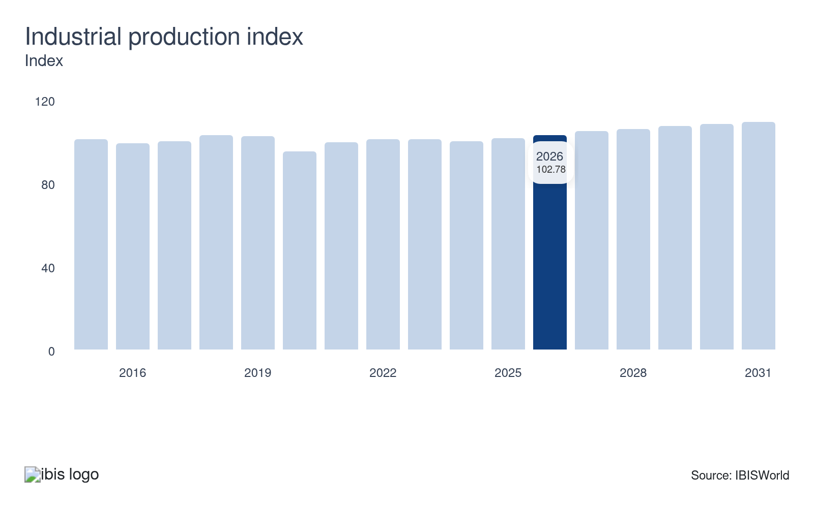
The industrial production index measures the mining, manufacturing, electric and gas output. When the industrial production index increases, relevant sectors are more willing to spend on transportation and warehousing services that arrange and complete transportation and storage of goods, commodities and manufacturing inputs. Declines in this index pose a potential threat to the sector.
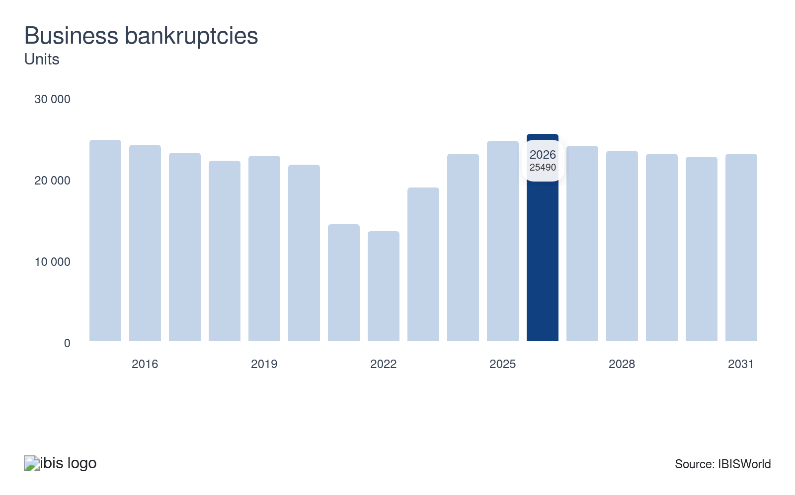
Business bankruptcies can significantly impact the sector by causing the loss of clientele that previously relied on these services, making this a threat. When bankruptcy rates weaken, businesses are more willing to maintain or strengthen their customer base, providing stability that is crucial for sustaining operations and revenue. This stability helps transportation and warehousing companies remain competitive and viable.

Regulation & Policy
Moderate | Steady

What regulations impact the industry?

FMCSA regulation limits the trucking industry
Tough Federal Motor Carrier Safety Administration (FMCSA) regulations impacted the trucking industry in 2024. According to these revised rules, drivers marked as "prohibited" in the FMCSA's Drug and Alcohol Clearinghouse because of positive drug or alcohol tests are not eligible to receive a commercial driving license. These regulations challenge companies trying to quickly fill positions and expand their operations. However, the FMCSA offers a potential relief for these stringent rules. If the industry's drug test failure rate remains below 1.0% for 2022 and 2023, the agency may reduce the required frequency of random drug testing to 25.0% in 2025. This reduction could help lower operating costs and reduce disruptions caused by random inspections, smoothing business operations.

FAA regulations impact airline pricing strategies
The FAA Reauthorization Act of 2024 has introduced new regulations prohibiting airlines from overcharging families to sit together on flights. This move targets a standard industry practice where airlines undertook pricing strategies that often led to families paying premiums for adjacent seats. This regulation impacts the airline transportation sector by limiting additional revenue channels from pricing tactics in a competitive market. As airlines can't offset costs through surcharges on family seating, there could be tighter profit. These limits on price hikes on clients underscore ongoing scrutiny of air travel pricing models and may influence similar strategies in other logistics-related sectors.

Assistance
Low | Steady

What assistance is available to this industry?

Federal Aviation Workforce Development Grant Program allocates funding
The airline segment within the sector receives aid from the federal government through the Federal Aviation Administration Reauthorization Act of 2024. This legislation allocates $60.0 million annually until 2028 for the Aviation Workforce Development Grant Program to train pilots and maintenance, repair and overhaul (MRO) engineers. The funding assists the air transportation segment by covering training expenses, allowing airlines to focus on core operations. Starting in 2025, an additional $5.0 million annually through 2028 will ease veterans' transition into airline pilot roles, partially relieving airlines from incentivizing pilots. This financial support positions the industry for operational expansion and market growth without the burden of additional training costs.

Federal-State Partnership for Intercity Passenger Rail (FSP) Grant Program
The Grant Program, authorized under the Infrastructure Investment and Jobs Act of 2021, aims to improve railway performance, including maintenance and repairs. From 2022 to 2026, the program received nearly $36.0 billion to support railway projects nationwide, focusing on developing new infrastructure and enhancing existing facilities and rails. In 2024, the program allocated $1.5 billion to upgrade stations in the Northeastern United States, explicitly targeting improvements in signal systems and replacing outdated infrastructure. These investments benefit the rail, transit and ground passenger transport segments by reducing train delays in the supported areas. Also, they provide railway companies with financial assistance to cover related costs.

Private support doesn't apply to the sector
The sector doesn't receive any private sector support.

9. Financial Benchmarks
https://my.ibisworld.com/us/en/industry/48-49/financial-benchmarks
Profit Margin  12.4 %  ↑ Higher than sector | Average Wage  $41,591  ↓ Lower than sector | Largest Cost  Other Costs  30.9% of Revenue

Key Takeaways
- Profit growth is increasingly concentrated in passenger-focused travel while freight margins stay weak. Higher-income travelers are paying for premium air and cruise products, but freight rate resets and soft trucking indexes are capping profit shares in cargo-heavy segments.
- Wage and purchase cost dynamics are being reshaped by self-employment and more disciplined capital spending. Owner-operators and gig workers absorb part of the freight downturn, while telematics and longer asset cycles let companies delay big-ticket purchases as fuel and equipment costs ease.

Cost Structure
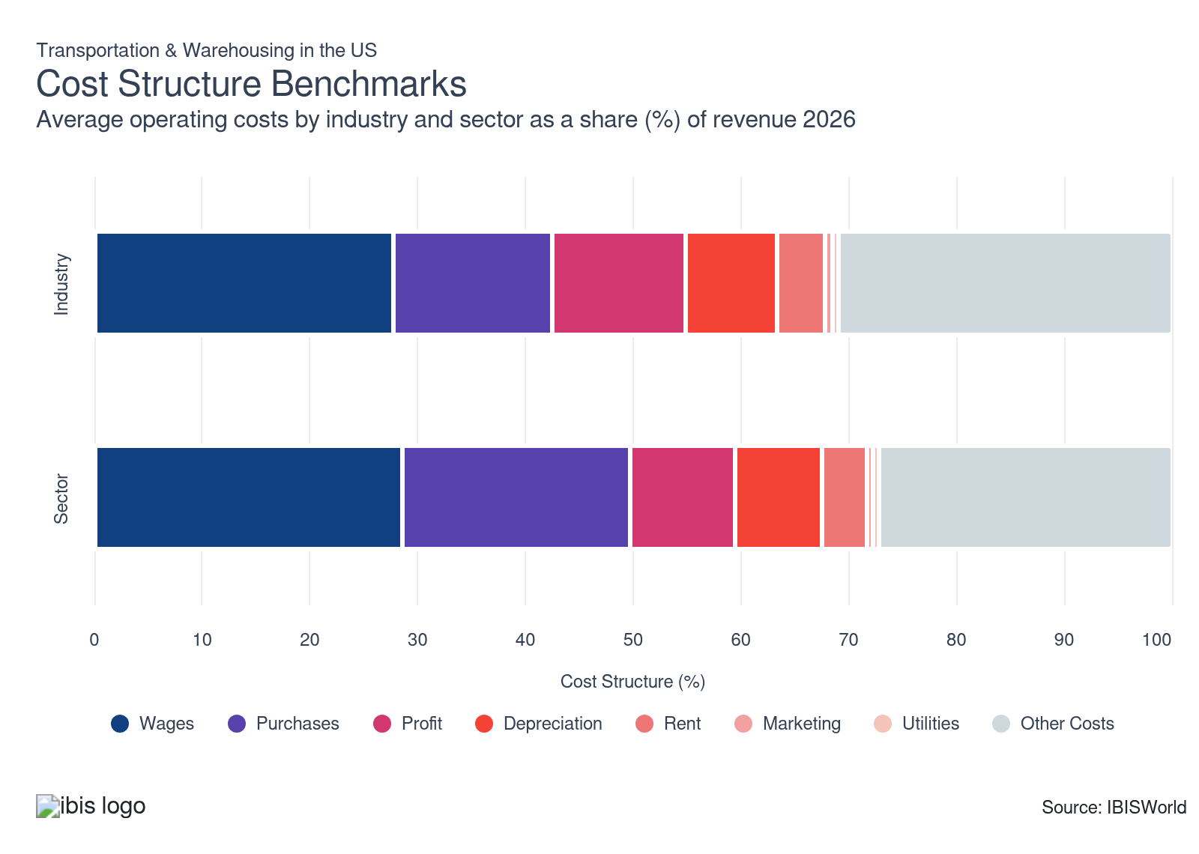
Chart displays current year only in the PDF version of this report. You can view and download chart for all other years associated with this industry on my.ibisworld.com.

What trends impact industry costs?

Travel recovery and weak freight pricing are reshaping profit shares
- Profit accounts for a growing share of revenue in passenger-focused transportation segments as demand for air travel and cruises rebounds. Rising disposable incomes among higher-earning households support premium economy seating on airlines and expand cruise bookings, lifting yields and helping travel operators expand profit margins despite higher service expectations.​
- For cargo transportation industries, profit shares are under pressure in freight-heavy segments as rates reset lower. A sharp correction in ocean and air cargo pricing has reduced carriers' revenue. It has filtered through to weaker trucking indexes, prompting cost-cutting through headcount reductions and lower procurement spending. Lower fuel prices, supported by stronger oil output, partially offset these pressures and prevent profit’s share of revenue from falling more steeply across the broader transportation and warehousing sector.​

Self-employment growth shifts wage cost dynamics
- Wage costs remain essential, particularly for manual and driving roles. Labor shortages led to wage increases in segments such as warehousing, while the ongoing need for workers kept labor expenses a sizable component of operating costs. The US Department of Transportation and the BLS reported that self-employed workers in transportation made up over 7.0% of the sector in 2022, matching 2020 levels and surpassing pre-pandemic figures.
- Over recent years, the influx of owner-operators and gig workers in areas like trucking and taxi services has changed the wage structure, narrowing wages as a share of total costs. As spot rates declined during the 2022 freight recession, wage compensation tied to these owner-operators dropped, reducing wage cost revenue share. Although figures have rebounded post-2022, ongoing spot-rate softness keeps growth modest.

Purchase costs ease as energy markets stabilize and asset cycles stretch
- Purchase costs rank as the third-largest expense in the sector, covering vehicles, containers, aircraft, and handling equipment that firms own rather than lease. Their share of revenue has inched lower as companies extend asset lifecycles and use telematics to manage fleets more efficiently, keeping new purchases focused on replacement needs rather than growth.
- Energy price recovery is reinforcing this moderation in purchasing activity. US Gulf Coast jet fuel averaged about $2.10 per gallon in 2025, down from roughly $3.30 in 2022, while Ship & Bunker reported VLSFO prices trending toward $417 per metric ton by 2027 as OPEC production increases. Lower fuel and material prices reduce cost pressures on new equipment, easing fleet-renewal outlays and keeping purchase costs manageable for capital-intensive operators.

Depreciation costs rise as asset reconfigurations and tax incentives accelerate write-offs
- Depreciation accounts for a moderate share of total sector costs, reflecting the long service lives of fleets, terminals, and handling equipment. While it seldom drives cash expenses like fuel or labor, its share of revenue has edged higher as companies adjust asset portfolios and modernize infrastructure.
- Network reconfigurations and policy incentives are lifting reported depreciation. UPS recorded roughly $58.0 million in accelerated depreciation in 2025 tied to closed facilities, as part of its property and equipment disposals. The 2025 OBBBA's bonus depreciation provision, which allows full expensing of new assets placed in service, also increases depreciation charges on balance sheets. These trends point to a temporary elevation in depreciation costs through 2026, especially among firms with significant capital turnover or restructuring programs.

Lease costs climb as newer fleet models push valuations higher
- These costs are the expenses companies pay to rent warehouses, storage units and supporting facilities for their operations. They make up a moderate share of a logistics company’s budget because the sector often requires extra space to handle incoming goods. To keep up with demand, companies must budget for not only warehouses but also offices and satellite locations needed to support their logistics activities.
- Rising vehicle valuations are a key driver of higher lease expenses. Penske Truck Leasing reported that truck and trailer lease payments increased by about 33% from 2020 to 2024, reflecting the introduction of costlier new models into fleets. As trucking and logistics operators refresh vehicle pools with upgraded or low-emission units, lease rates follow market valuations upward, lifting overall rental and leasing costs through 2025 and into 2026.

Utility costs decline as energy efficiency technologies cut facility consumption
- Utility expenses account for a small share of sector costs, covering electricity for lighting, material handling, and IT systems, as well as natural gas for building heating. Their revenue share has gradually fallen as warehouses and terminals adopt smarter, more efficient systems that lower energy use per square foot.
- Major operators are driving these reductions through automation and AI-based energy management. Amazon introduced BrainBox AI across grocery fulfillment centers, lowering energy intensity by about 15.0% in 2025. Airports and logistics hubs have also installed LED lighting and advanced control systems to reduce electricity demand. These investments have pushed utility costs on a sliding scale through 2025, reinforcing the sector’s long-term trend of declining energy expenses relative to total operating outlays.

Marketing costs rise as 3PLs expand AI-driven customer engagement
- Marketing remains a small share of sector expenses, reflecting the sector’s focus on service quality and contractual relationships over mass advertising. Its revenue share has inched upward as third-party logistics firms invest more in digital outreach, data platforms, and customer-facing technology to compete in a crowded market.
- Spending growth stems from increased adoption of AI tools to enhance marketing performance and client engagement. A 2025 Extensiv survey found that about 33.7% of 3PLs plan to implement AI functionalities, with 14% viewing them as major drivers of marketing strategy. These investments raise short-term marketing outlays through software integration and training but position firms to expand lead generation and retention capabilities, pushing marketing costs higher across the sector through 2026.
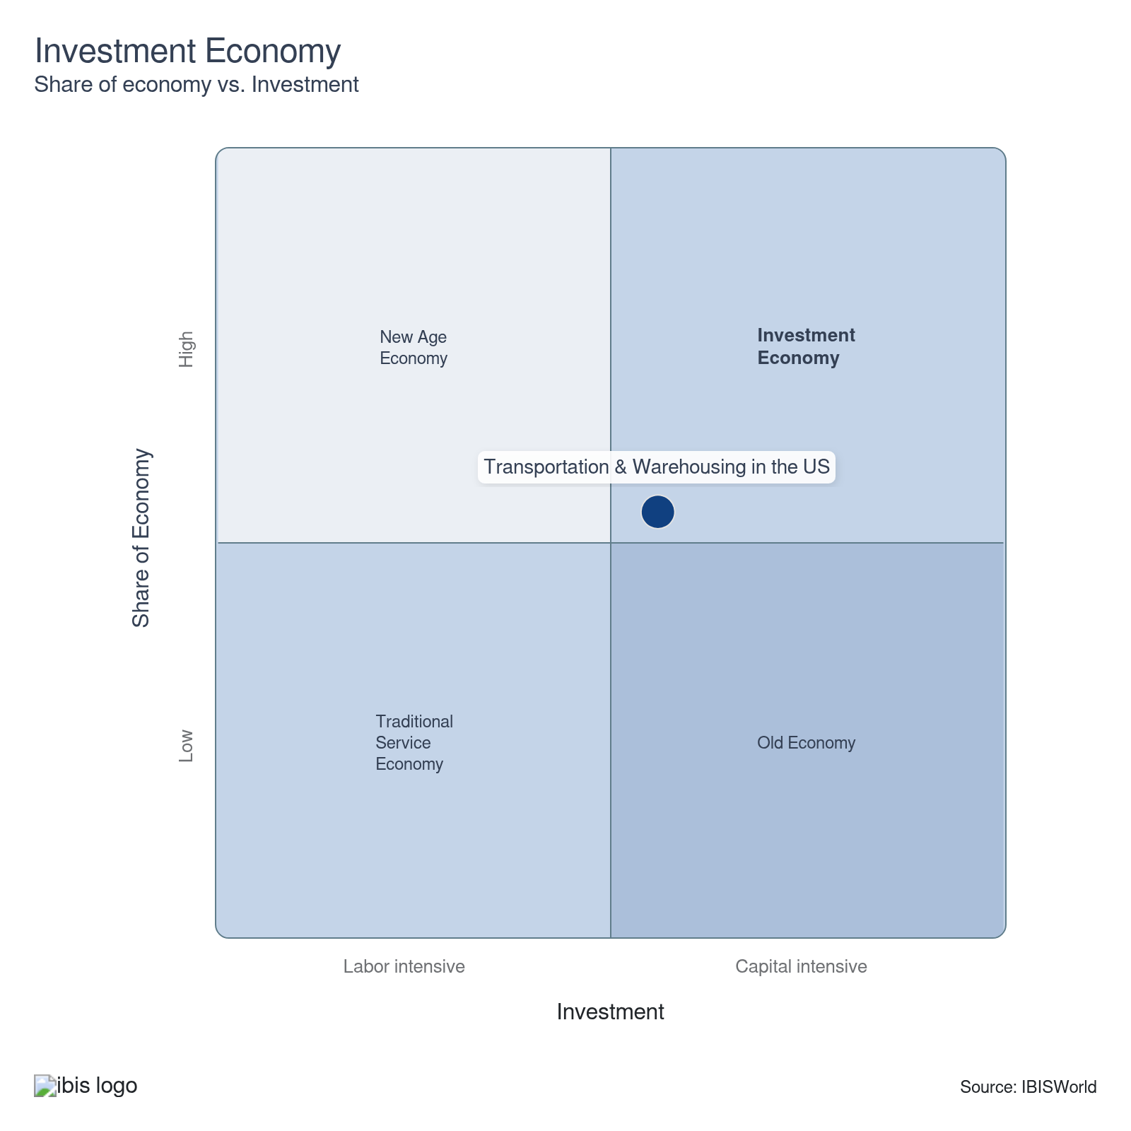

Key Ratios
Year | Revenue per Employee  ($) | Revenue per Enterprise  ($ Million) | Employees per Estab.  (Units) | Employees per Enterprise  (Units) | Average Wage  ($) | Wages/ Revenue  (%) | Estab. per Enterprise  (Units) | IVA/ Revenue  (%)
2006 | 203,220 | 1.2 | 5.6 | 6.0 | 61,459 | 30.2 | 1.1 | 49.1
2007 | 202,995 | 1.2 | 5.4 | 5.8 | 60,365 | 29.7 | 1.1 | 47.9
2008 | 209,716 | 1.2 | 5.5 | 6.0 | 58,789 | 28.0 | 1.1 | 45.2
2009 | 192,975 | 1.1 | 5.4 | 5.8 | 58,820 | 30.5 | 1.1 | 49.3
2010 | 209,779 | 1.2 | 5.2 | 5.6 | 60,243 | 28.7 | 1.1 | 47.5
2011 | 219,601 | 1.2 | 5.2 | 5.6 | 60,495 | 27.5 | 1.1 | 46.9
2012 | 220,713 | 1.2 | 5.2 | 5.6 | 60,231 | 27.3 | 1.1 | 45.9
2013 | 221,682 | 1.2 | 5.1 | 5.5 | 60,182 | 27.1 | 1.1 | 46.0
2014 | 223,450 | 1.2 | 4.8 | 5.1 | 60,043 | 26.9 | 1.1 | 45.3
2015 | 210,137 | 1.0 | 4.4 | 4.6 | 58,537 | 27.9 | 1.1 | 47.5
2016 | 200,069 | 0.8 | 4.0 | 4.2 | 57,766 | 28.9 | 1.0 | 48.6
2017 | 196,127 | 0.7 | 3.5 | 3.7 | 54,789 | 27.9 | 1.0 | 47.9
2018 | 195,608 | 0.7 | 3.2 | 3.4 | 53,003 | 27.1 | 1.0 | 47.4
2019 | 186,718 | 0.6 | 3.1 | 3.2 | 51,368 | 27.5 | 1.0 | 49.3
2020 | 155,506 | 0.5 | 3.0 | 3.0 | 48,454 | 31.2 | 1.0 | 48.7
2021 | 168,719 | 0.5 | 2.7 | 2.8 | 47,892 | 28.4 | 1.0 | 46.9
2022 | 178,946 | 0.5 | 2.7 | 2.8 | 45,051 | 25.2 | 1.0 | 45.0
2023 | 164,143 | 0.5 | 2.8 | 2.8 | 44,167 | 26.9 | 1.0 | 47.6
2024 | 158,868 | 0.4 | 2.6 | 2.6 | 43,273 | 27.2 | 1.0 | 48.3
2025 | 156,065 | 0.4 | 2.4 | 2.5 | 43,001 | 27.6 | 1.0 | 48.1
2026 | 149,686 | 0.4 | 2.3 | 2.3 | 41,591 | 27.8 | 1.0 | 48.6
2027 | 146,051 | 0.3 | 2.2 | 2.2 | 40,787 | 27.9 | 1.0 | 48.4
2028 | 143,456 | 0.3 | 2.1 | 2.1 | 40,205 | 28.0 | 1.0 | 48.4
2029 | 141,240 | 0.3 | 2.0 | 2.1 | 39,689 | 28.1 | 1.0 | 48.4
2030 | 139,274 | 0.3 | 1.9 | 2.0 | 39,206 | 28.2 | 1.0 | 48.5
2031 | 137,415 | 0.3 | 1.9 | 1.9 | 38,753 | 28.2 | 1.0 | 48.6
2032 | 135,560 | 0.3 | 1.8 | 1.8 | 38,649 | 28.5 | 1.0 | 48.7
*Figures are inflation adjusted to 2026
*Figures are inflation adjusted to 2026

10. Key Statistics
https://my.ibisworld.com/us/en/industry/48-49/key-statistics

Industry Data

Values
Year | Revenue  ($ Million) | IVA  ($ Million) | Estab.  (Units) | Enterprises  (Units) | Employment  (Units) | Wages  ($ Million)
2006 | 1,341,005.6 | 658,016.6 | 1,184,602 | 1,104,675 | 6,598,788 | 405,558.2
2007 | 1,374,645.6 | 658,955.9 | 1,257,922 | 1,175,261 | 6,771,816 | 408,778.6
2008 | 1,415,152.2 | 640,309.7 | 1,216,650 | 1,133,059 | 6,747,935 | 396,704.0
2009 | 1,228,310.4 | 605,312.9 | 1,172,160 | 1,089,049 | 6,365,131 | 374,396.2
2010 | 1,299,569.5 | 617,039.5 | 1,185,590 | 1,103,478 | 6,194,958 | 373,200.6
2011 | 1,380,872.9 | 647,513.0 | 1,203,882 | 1,121,117 | 6,288,102 | 380,400.3
2012 | 1,415,862.0 | 650,555.9 | 1,222,585 | 1,141,609 | 6,414,942 | 386,378.9
2013 | 1,438,602.6 | 662,082.2 | 1,261,919 | 1,181,119 | 6,489,482 | 390,552.9
2014 | 1,504,895.3 | 681,902.4 | 1,390,966 | 1,308,532 | 6,734,807 | 404,377.8
2015 | 1,511,480.1 | 718,317.5 | 1,637,534 | 1,553,204 | 7,192,842 | 421,047.8
2016 | 1,514,831.9 | 735,712.3 | 1,903,203 | 1,818,271 | 7,571,534 | 437,380.9
2017 | 1,586,616.6 | 760,208.1 | 2,287,067 | 2,200,499 | 8,089,727 | 443,231.1
2018 | 1,688,511.8 | 799,731.6 | 2,662,747 | 2,576,080 | 8,632,136 | 457,530.0
2019 | 1,736,802.5 | 856,541.9 | 2,969,788 | 2,882,497 | 9,301,740 | 477,808.9
2020 | 1,531,363.3 | 745,667.0 | 3,317,083 | 3,229,679 | 9,847,600 | 477,152.4
2021 | 1,737,813.4 | 814,995.3 | 3,746,256 | 3,657,891 | 10,300,075 | 493,292.1
2022 | 1,961,829.7 | 883,784.3 | 3,991,626 | 3,901,482 | 10,963,268 | 493,906.6
2023 | 1,903,210.8 | 906,296.7 | 4,172,434 | 4,076,134 | 11,594,815 | 512,110.7
2024 | 1,873,567.6 | 904,038.1 | 4,567,275 | 4,464,628 | 11,793,210 | 510,323.3
2025 | 1,901,283.3 | 914,222.1 | 5,012,746 | 4,903,924 | 12,182,611 | 523,859.1
2026 | 1,887,254.1 | 916,990.4 | 5,500,583 | 5,385,572 | 12,608,075 | 524,381.4
2027 | 1,917,507.2 | 928,675.4 | 6,053,309 | 5,930,228 | 13,129,062 | 535,500.7
2028 | 1,945,182.2 | 940,754.5 | 6,505,658 | 6,373,899 | 13,559,465 | 545,153.8
2029 | 1,974,680.6 | 956,242.9 | 6,937,049 | 6,795,535 | 13,981,035 | 554,897.7
2030 | 2,007,117.5 | 974,092.5 | 7,413,121 | 7,261,698 | 14,411,307 | 565,005.7
2031 | 2,037,855.1 | 989,540.3 | 7,934,796 | 7,774,128 | 14,829,888 | 574,706.9
2032 | 2,055,151.7 | 1,001,518.9 | 8,353,063 | 8,207,124 | 15,160,463 | 585,931.2

*Figures are inflation adjusted to 2026

Annual Change
Year | Revenue  % | IVA  % | Estab.  % | Enterprises  % | Employment  % | Wages  %
2006 | N/A | N/A | N/A | N/A | N/A | N/A
2007 | 2.5 | 0.1 | 6.2 | 6.4 | 2.6 | 0.8
2008 | 2.9 | -2.8 | -3.3 | -3.6 | -0.4 | -3.0
2009 | -13.2 | -5.5 | -3.7 | -3.9 | -5.7 | -5.6
2010 | 5.8 | 1.9 | 1.1 | 1.3 | -2.7 | -0.3
2011 | 6.3 | 4.9 | 1.5 | 1.6 | 1.5 | 1.9
2012 | 2.5 | 0.5 | 1.6 | 1.8 | 2.0 | 1.6
2013 | 1.6 | 1.8 | 3.2 | 3.5 | 1.2 | 1.1
2014 | 4.6 | 3.0 | 10.2 | 10.8 | 3.8 | 3.5
2015 | 0.4 | 5.3 | 17.7 | 18.7 | 6.8 | 4.1
2016 | 0.2 | 2.4 | 16.2 | 17.1 | 5.3 | 3.9
2017 | 4.7 | 3.3 | 20.2 | 21.0 | 6.8 | 1.3
2018 | 6.4 | 5.2 | 16.4 | 17.1 | 6.7 | 3.2
2019 | 2.9 | 7.1 | 11.5 | 11.9 | 7.8 | 4.4
2020 | -11.8 | -12.9 | 11.7 | 12.0 | 5.9 | -0.1
2021 | 13.5 | 9.3 | 12.9 | 13.3 | 4.6 | 3.4
2022 | 12.9 | 8.4 | 6.5 | 6.7 | 6.4 | 0.1
2023 | -3.0 | 2.5 | 4.5 | 4.5 | 5.8 | 3.7
2024 | -1.6 | -0.2 | 9.5 | 9.5 | 1.7 | -0.3
2025 | 1.5 | 1.1 | 9.8 | 9.8 | 3.3 | 2.7
2026 | -0.7 | 0.3 | 9.7 | 9.8 | 3.5 | 0.1
2027 | 1.6 | 1.3 | 10.0 | 10.1 | 4.1 | 2.1
2028 | 1.4 | 1.3 | 7.5 | 7.5 | 3.3 | 1.8
2029 | 1.5 | 1.6 | 6.6 | 6.6 | 3.1 | 1.8
2030 | 1.6 | 1.9 | 6.9 | 6.9 | 3.1 | 1.8
2031 | 1.5 | 1.6 | 7.0 | 7.1 | 2.9 | 1.7
2032 | 0.8 | 1.2 | 5.3 | 5.6 | 2.2 | 2.0

*Figures are inflation adjusted to 2026

DISCLAIMER
This product has been supplied by IBISWorld Inc. (‘IBISWorld’) solely for use by its authorized licenses strictly in accordance with their license agreements with IBISWorld. IBISWorld makes no representation to any other person with regard to the completeness or accuracy of the data or information contained herein, and it accepts no responsibility and disclaims all liability (save for liability which cannot be lawfully disclaimed) for loss or damage whatsoever suffered or incurred by any other person resulting from the use of, or reliance upon, the data or information contained herein. Copyright in this publication is owned by IBISWorld Inc. The publication is sold on the basis that the purchaser agrees not to copy the material contained within it for other than the purchasers own purposes. In the event that the purchaser uses or quotes from the material in this publication – in papers, reports, or opinions prepared for any other person – it is agreed that it will be sourced to: IBISWorld Inc.

